**Breeding Bird Monitoring Protocol for the Heartland Inventory and Monitoring Network**

**Standard Operation Procedure 8: Reporting**

**Version 3.00 (03/17/2020)**

**Revision History Log:**

|  |  |  |  |  |  |
| --- | --- | --- | --- | --- | --- |
| Previous Version # | Revision Date | Author | Changes Made | Reason for Change | New Version # |
| 1.01 | May 2008 | D.G. Peitz | Entire document | Edited to reflect that bird monitoring has been expanded to ten additional network parks | 2.00 |
| 2.00 | May 2019 | D.G. Peitz | Clarified types of reports. Added operational review section. Added peer review section. | Integrates WASO reporting and peer review guidance | 3.00 |
|  |  |  |  |  |  |
|  |  |  |  |  |  |
|  |  |  |  |  |  |

## Reporting Types and Frequency

This Standard Operating Procedure (SOP) describes the administrative, operational, and scientific reporting requirements for breeding bird monitoring on National Park Service lands within the Heartland Inventory and Monitoring Network (HTLN). We monitor parks on a 4-year return cycle (see narrative) and reporting is defined around this monitoring schedule. Volunteers or park staff conduct monitoring in years when HTLN staff does not.

1. **Trip Reports**

*Description:* Trip reports should include a description of the trip’s mission, participants, and daily activities. Specific to bird monitoring are notes on unusual bird activity, obstructions to hearing birds, significant natural resource management actions, and changes in weather conditions. These reports are an invaluable record of field data collection efforts. The format of trip reports is flexible. The project leader authors the trip report with input from the sampling team, and the program manager reviews the trip report. Trip reports are stored on the HTLN server in the project’s “TripReports” folder.

*Objectives:* Document field operations and conditions. Identify noteworthy field circumstances. Document issues requiring follow-up.

*Frequency:* Within one month after each monitoring event.

1. **Operational Review and Report**

*Description:* Inventory and Monitoring Division protocol review guidance requires annual operational reviews of all implemented protocols (Mitchell et al. 2018). Mitchell et al. (2018) prescribes the following required outcomes of the operational review.

* Documentation of suggestions for improving the protocol and decisions regarding the suggestions. Note that some suggestions may trigger a scientific review.
* Documentation of deviations between the protocol and the field implementation that could potentially affect data quality or utility. For these deviations, document whether the deviation needs to be addressed with changes or clarifications to procedures. Update the database with affected data appropriately flagged and documented.
* Updated and approved protocol documents or an approved plan (tasks and timeline) for revising the protocol if procedures, methods, or equipment are changed or clarified. Approved plans may include a pilot study, data analysis, and scientific review.
* Identification and verification that safety risks associated with protocol implementation are appropriately mitigated. For any newly identified or incompletely mitigated risks, approve a plan (tasks and timeline) for mitigating the risks and updating the network safety documents.

The project lead conducts the operational review and data quality assessment, and authors the final report with input from the sampling team. The program manager reviews the report. Final reports are stored on the HTLN server in the project’s “Operational Review” report folder. A report template and checklist are provided in Appendix A.

*Objectives:* Document the continuous learning and clarification of protocol details and safety issues. Evaluates field crew effectiveness in implementing the protocol.

### *Frequency:* Every fourth year (i.e. the year a particular park is sampled by HTLN staff).

1. **Annual reports**

*Description*: These updates are in the form of a species list of birds recorded on a park by non-HTLN volunteers or staff. Annual reports are limited to routine analysis based on data collection and analysis methods from a well-established, peer-reviewed protocol. Content should be drafted and provided to HTLN web support personnel. A 9th grade reading level is preferred for public audiences. It is recommended to utilize a narrative or story format known as the ABT when possible (Olson 2009). Annual updates should include a table of species observed, their residency status, abundance, frequency of occurrence. See Appendix B for an example of annual reporting.

*Objectives*: Provide managers and volunteer birders a summary of an annual data collection including species residency, abundance, and frequency on a park at the time of surveys.

### *Frequency:* Annually for parks surveyed by non-HTLN volunteers or staff.

1. **Trend and Synthesis reports**

### *Description*: Trend and Synthesis reports describe the standard metrics through time including the most recent visit and prior monitoring visits. Statistics may be used to summarize and present the data in a user-friendly manner as well as to determine if the trend is statistically or ecologically significant when needed. These reports may often be constructed for inclusion in the Natural Resource Data Series (NRDS) or Natural Resource Report (NRR) format. An NRDS format is appropriate when the trend report is limited to routine analysis. An NRR format is appropriate when more in-depth analysis is included. Trend reports may take a *baseline report* format if new monitoring is initiated in a new park or park unit. Publication of data in peer reviewed scientific journals will also serve as an acceptable trend report. See Appendix C for an example of a trend report.

*Objectives*: These reports should provide: 1) a description of the data, summary information including tables and graphs, and highlight relevant trends 2) context for the metric and status or trend when appropriate 3) identify significant temporal changes in the species composition of bird communities and 4) the relationships between breeding birds, their habitat, and the effects of environmental or other explanatory variables.

### *Frequency:* Every fourth year (i.e. the year a particular park is sampled by HTLN staff).

### **Reporting Series, Templates and Style**

The report templates for the Natural Resource Publication Series (NRPS) should be followed (https://www.nps.gov/im/publication-series.htm). Consult the NRPS website to choose the correct template with which to begin writing. Always start with a fresh template as templates change periodically and old templates can become corrupted. If the report will be sent to a specialist for design and layout, use the author templates.

The Natural Resource Data Series (NRDS) is a non-scholarly series intended for the timely release of basic data sets and data summaries. Data reported in the NRDS are limited to those collected, processed (undergone quality assurance and quality control procedures), and analyzed following methods prescribed in peer-reviewed and published NPS Inventory & Monitoring protocols.

The Natural Resource Report Series (NRR) is used to disseminate information and analysis about natural resources and related topics concerning lands managed by the National Park Service. The series supports the advancement of science, informed decision making, and the achievement of the National Park Service mission. The series also provides a forum for presenting lengthy results that may not be accepted by publications with page limitations.

Standards for scientific writing as recommended in the CBE Style Manual (CBE Style Manual Committee 1994) should be followed. Reports should be direct and concise. Refer also to Mack (1986), Day and Gastel (2012), and Strunk and White (1979) for guidelines on appropriate writing style.

## Report peer review

In 2017, the National Park Service Inventory and Monitoring Division (IMD or the Division) issued guidance to IMD staff on the implementation of a peer review process outlined in an interim document issued by the National Park Service in 2008 (NPS 2008). The network’s Process for Implementing Peer Review and Reporting Policy document provides step by step procedures for implementing the division’s guidelines.

Data reported in the NRDS are limited to those collected, processed (undergone quality assurance and quality control procedures), and analyzed following methods prescribed in peer-reviewed and published NPS Inventory & Monitoring protocols. As such, no further peer review is required.

In many cases, data reported in the NRR series may also be exempt from additional peer review if analyzed following methods in peer-reviewed and published NPS Inventory & Monitoring protocols. In some cases, however, natural resource reports will expand and enhance upon the basic analyses and summaries provided in the protocols and will require peer review. Authors should consult with their supervisor and peer review manager to determine the appropriate level of peer review.

Generally, peer review begins when the document is sent to the program manager who assigns peer reviewers and a peer review manager. The review(s) are sent to the peer review manager who then passes on the required changes to the report author(s). After changes are made a response with the new report draft are forwarded to the peer review manager. Upon approval of the manuscript, the author should obtain a management review from the park. After those results are incorporated, a final draft is given to the peer review manager. After approval, the author may send the report to be formatted. After formatting, a manuscript submittal form is completed, and the report submitted via the manuscript submittal portal.

**Report Distribution**

All reports are permanently archived in the Integrated Resource Management Application (IRMA) (<https://irma.nps.gov/DataStore/>). Reports are posted to the Heartland Network web site (<https://www.nps.gov/im/htln/index.htm>), and tagged so that parks may share through their web sites. Copies of the report, or at a minimum a personal email with the link to the report, are sent to the resource management staff and the superintendent. All data collected are public property and subject to requests under the Freedom of Information Act (FOIA).

**References**

CBE Style Manual Committee. 1994. Scientific style and format: the CBE manual for authors, editors and publishers. Sixth edition. Council of Biology Editors, Cambridge University Press, New York, New York, USA.

Day, R., and B. Gastel. 2012. How to write and publish a scientific paper. Cambridge University Press, Cambridge.

Mack, R.N. 1986. Writing with precision, clarity and economy. Bulletin of Ecological Society of America 67:31-35.

Mitchell, B., A. Chung-MacCoubrey, J. Comiskey, L. Garrett, M. MacCluskie, B. Moore, T. Philippi, G. Sanders, and J.P. Schmit. 2018. Inventory and Monitoring Division protocol review guidance. Natural Resource Report NPS/NRSS/IMD/NRR—2018/1644. National Park Service, Fort Collins, Colorado.

National Park Service (NPS). 2008. [Interim Guidance Document Governing Code of Conduct, Peer Review, and Information Quality Correction for National Park Service Cultural and Natural Resource Disciplines](https://irma.nps.gov/DataStore/DownloadFile/474958).

National Park Service. 2017. Peer review, publication, and administrative recordkeeping requirements for scholarly and science information disseminated by the NPS Inventory and Monitoring Division. Inventory and Monitoring Division. Fort Collins, CO

Olson, R. 2009. Don’t be such a scientist: Talking substance in an age of style. Island Press, 216 pages.

Strunk, W. Jr. and E.B. White. 1979. The Elements of Style. Fourth Edition. Macmillan, New York, New York, USA.

**SOP 8 – Appendix A. Annual Operations Review and Data Quality Assessment Checklist**

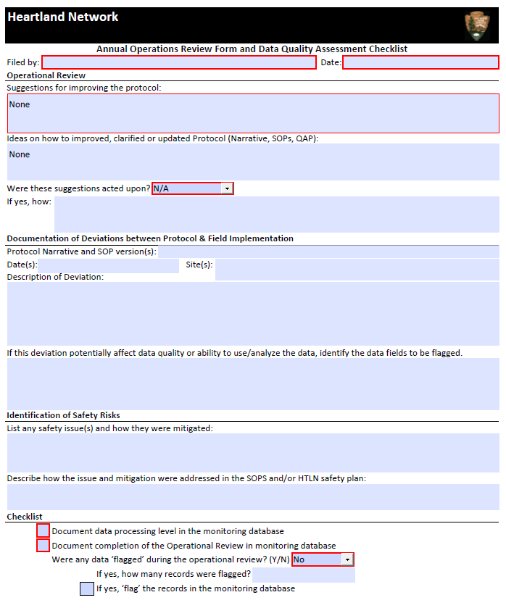

**SOP 8 – Appendix B. Example Annual Report**

Table 1. Number of individuals encountered per plot visit, and proportion of plots out of 24 occupied by breeding bird species at George Washington Carver National Monument, Missouri during the 2017 bird surveys. Number of individuals per plot, and proportion of plots occupied includes all individuals recorded on plots during a 5-minute survey, including flyovers.

|  |  |  |  |
| --- | --- | --- | --- |
| Common name | Residency1 | Individuals / plot visit | Proportion of plots occupied |
| Acadian Flycatcher | SR | 0.04 | 0.04 |
| American Coot | SR | 0.04 | 0.04 |
| American Crow | R | 0.42 | 0.25 |
| American Goldfinch | R | 0.50 | 0.21 |
| American Kestrel* | SR | -- | -- |
| American Robin | R | 0.25 | 0.25 |
| Baltimore Oriole* | SR | -- | -- |
| Barn Swallow | SR | 0.17 | 0.08 |
| **Bell’s Vireo\*** | **SR** | **--** | **--** |
| Blue Jay | R | 0.04 | 0.04 |
| Blue-gray Gnatcatcher | SR | 0.21 | 0.17 |
| Brown-headed Cowbird | R | 0.29 | 0.25 |
| Brown Thrasher | R | 0.04 | 0.04 |
| Carolina Chickadee | R | 0.13 | 0.08 |
| Carolina Wren | R | 0.50 | 0.38 |
| Common Grackle* | R | -- | -- |
| Common Yellowthroat | SR | 0.21 | 0.17 |
| Dickcissel | SR | 2.21 | 0.67 |
| Eastern Bluebird | R | 0.04 | 0.04 |
| Eastern Kingbird | SR | 0.08 | 0.08 |
| Eastern Meadowlark | SR | 0.25 | 0.17 |
| Eastern Phoebe | R | 0.17 | 0.13 |
| Eastern Towhee | R | 0.04 | 0.04 |
| Eastern Wood-pewee | SR | 0.21 | 0.17 |
| European Starling | R | 0.08 | 0.04 |
| Field Sparrow | R | 0.25 | 0.21 |
| Great Blue Heron* | SR | -- | -- |
| Great Crested Flycatcher | SR | 0.04 | 0.04 |
| Great Horned Owl | R | 0.04 | 0.04 |
| House Sparrow | R | 0.08 | 0.04 |
| House Wren | SR | 0.04 | 0.04 |
| Indigo Bunting | SR | 0.33 | 0.29 |
| **Kentucky Warbler** | **SR** | **0.04** | **0.04** |
| Louisiana Waterthrush | SR | 0.04 | 0.04 |
| Mourning Dove | R | 0.21 | 0.17 |
| Northern Bobwhite | R | 0.17 | 0.17 |
| Northern Cardinal | R | 0.71 | 0.58 |
| Northern Flicker | R | 0.04 | 0.04 |
| Northern Mockingbird | R | 0.17 | 0.17 |
| Northern Parula | SR | 0.21 | 0.21 |
| Orchard Oriole* | SR | -- | -- |
| Pileated Woodpecker | R | 0.13 | 0.13 |
| Prothonotary Warbler | SR | 0.04 | 0.04 |
| Red-bellied Woodpecker | R | 0.46 | 0.42 |
| Red-eyed Vireo | SR | 0.04 | 0.04 |
| **Red-headed Woodpecker\*** | **SR** | **--** | **--** |
| Red-tailed Hawk | R | 0.04 | 0.04 |
| Red-winged Blackbird | R | 0.13 | 0.08 |
| Ruby-throated Hummingbird | SR | 0.04 | 0.04 |
| Scissor-tailed Flycatcher | SR | 0.13 | 0.08 |
| Summer Tanager | SR | 0.04 | 0.04 |
| Tufted Titmouse | R | 0.50 | 0.50 |
| Turkey Vulture | R | 0.25 | 0.08 |
| White-breasted Nuthatch | R | 0.08 | 0.08 |
| White-eyed Vireo | SR | 0.04 | 0.04 |
| Yellow-billed Cuckoo | SR | 0.25 | 0.21 |

1 Residency status: R = year around resident; SR = summer resident (Robbins and Easterla 1992).

* Denotes species only recorded outside the 5-min survey period.

Bolded species names are those species considered of conservation concern for the Central Hardwoods Bird Conservation Region (U.S. Fish and Wildlife Service 2008).

**SOP 8 – Appendix C. Example Trend Report**

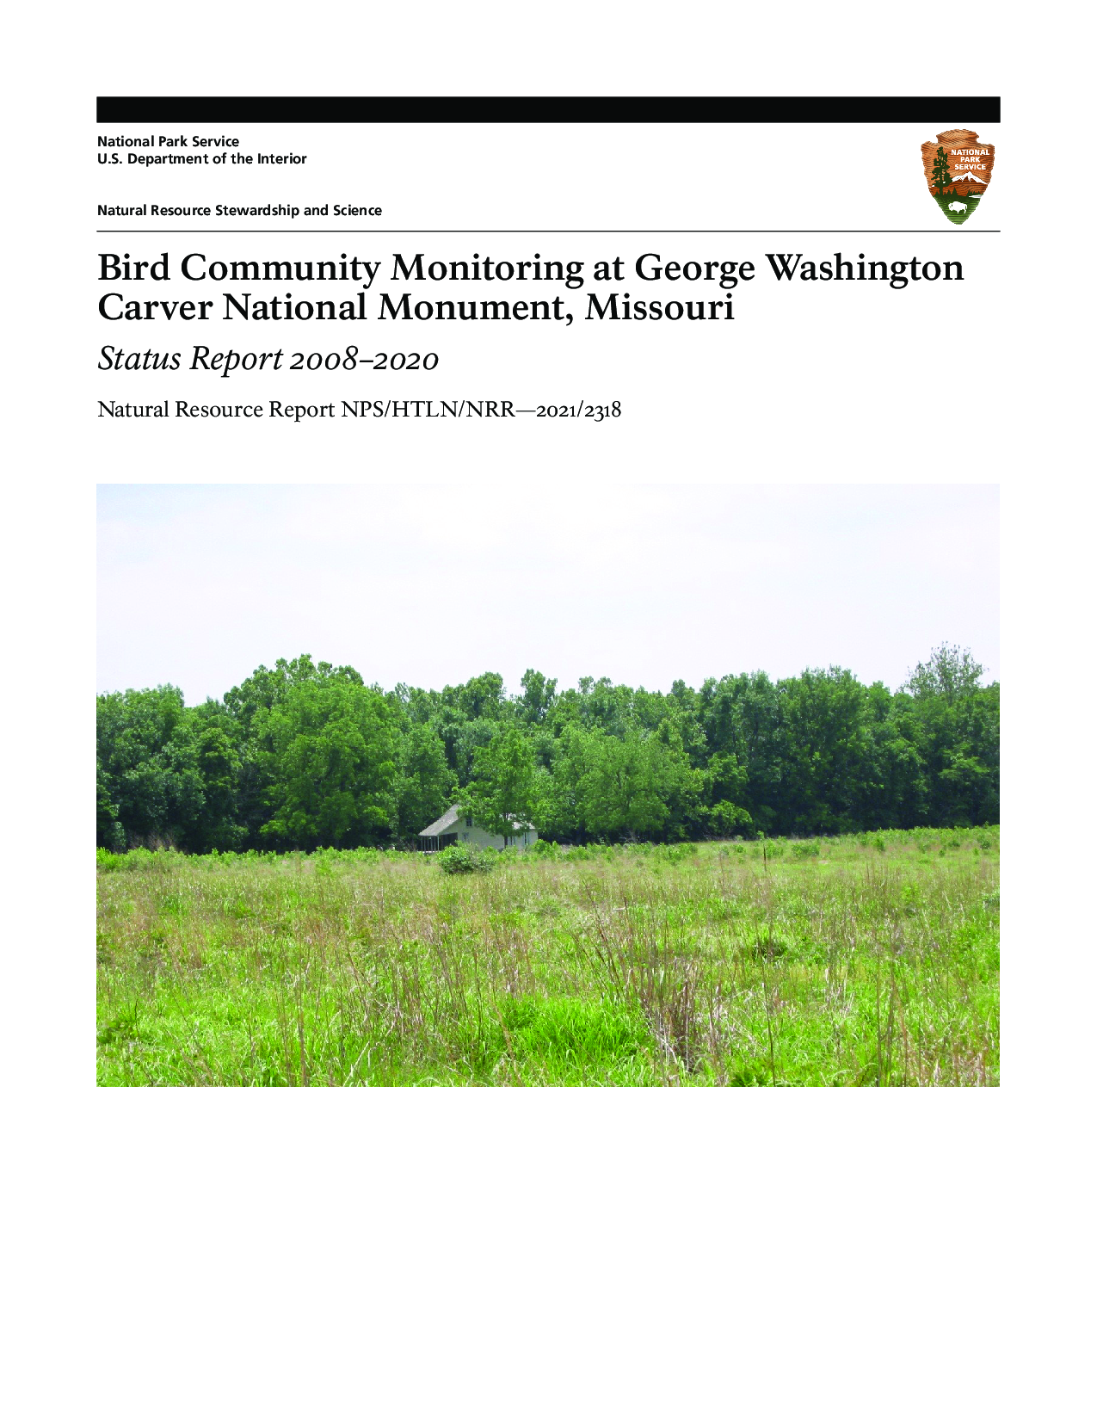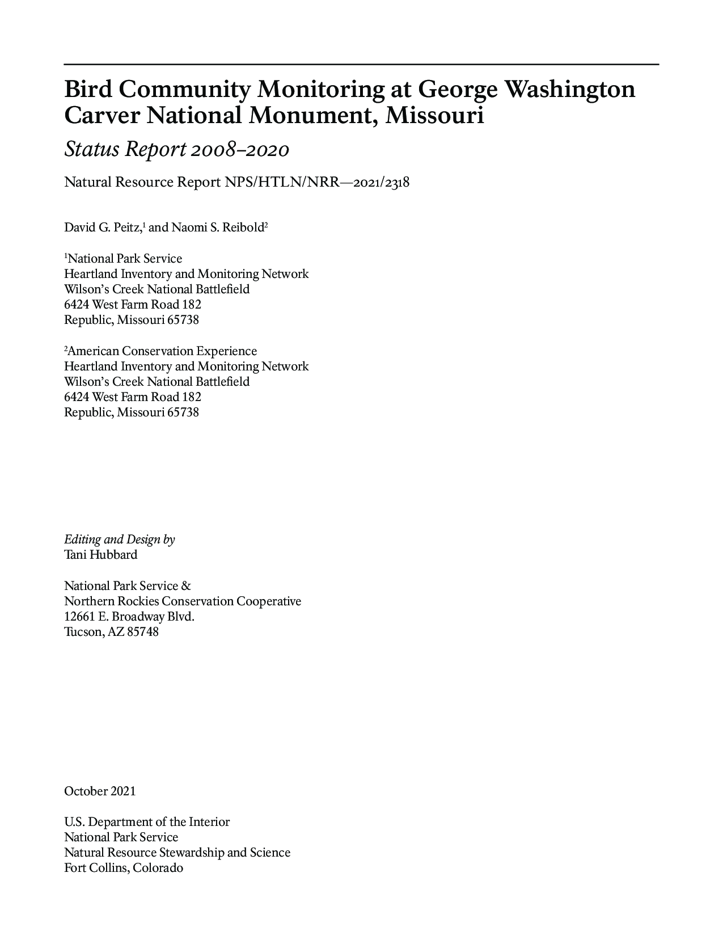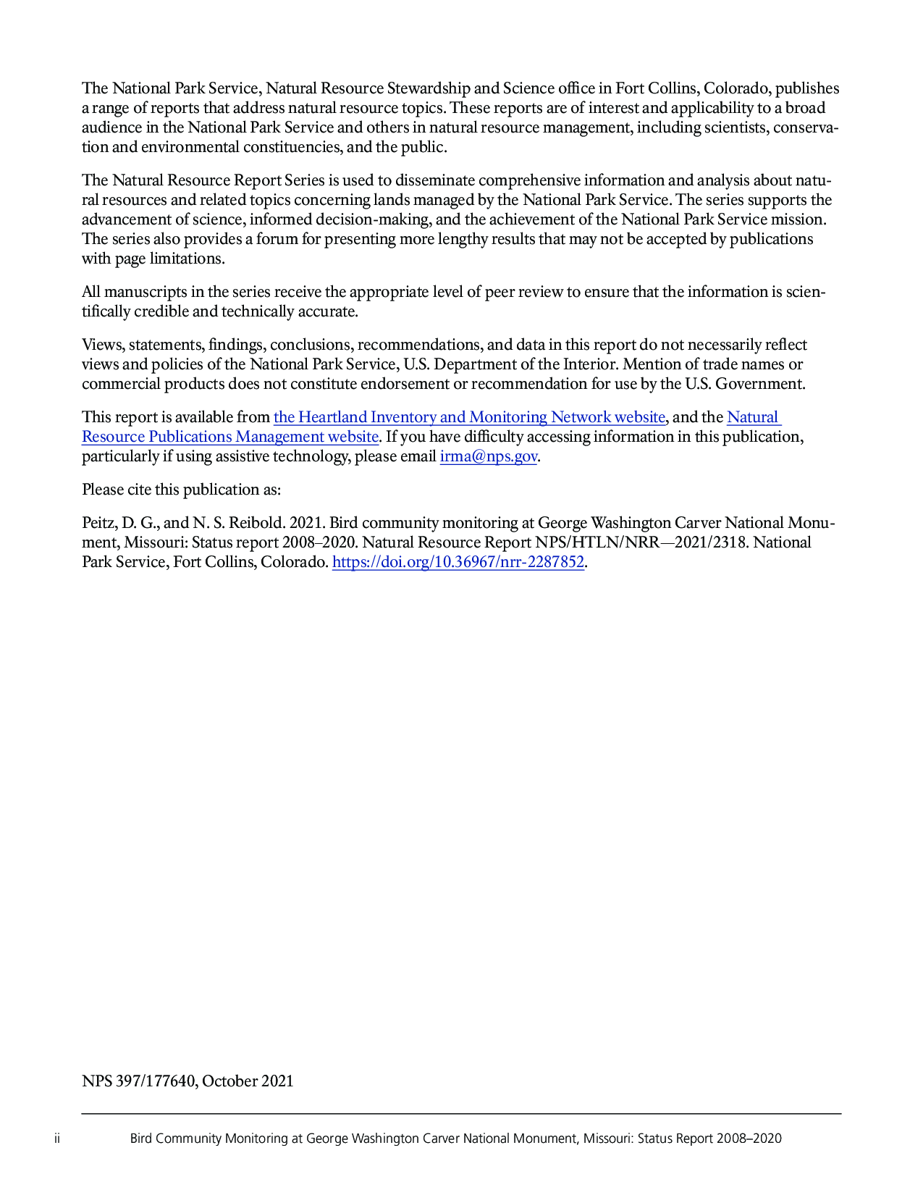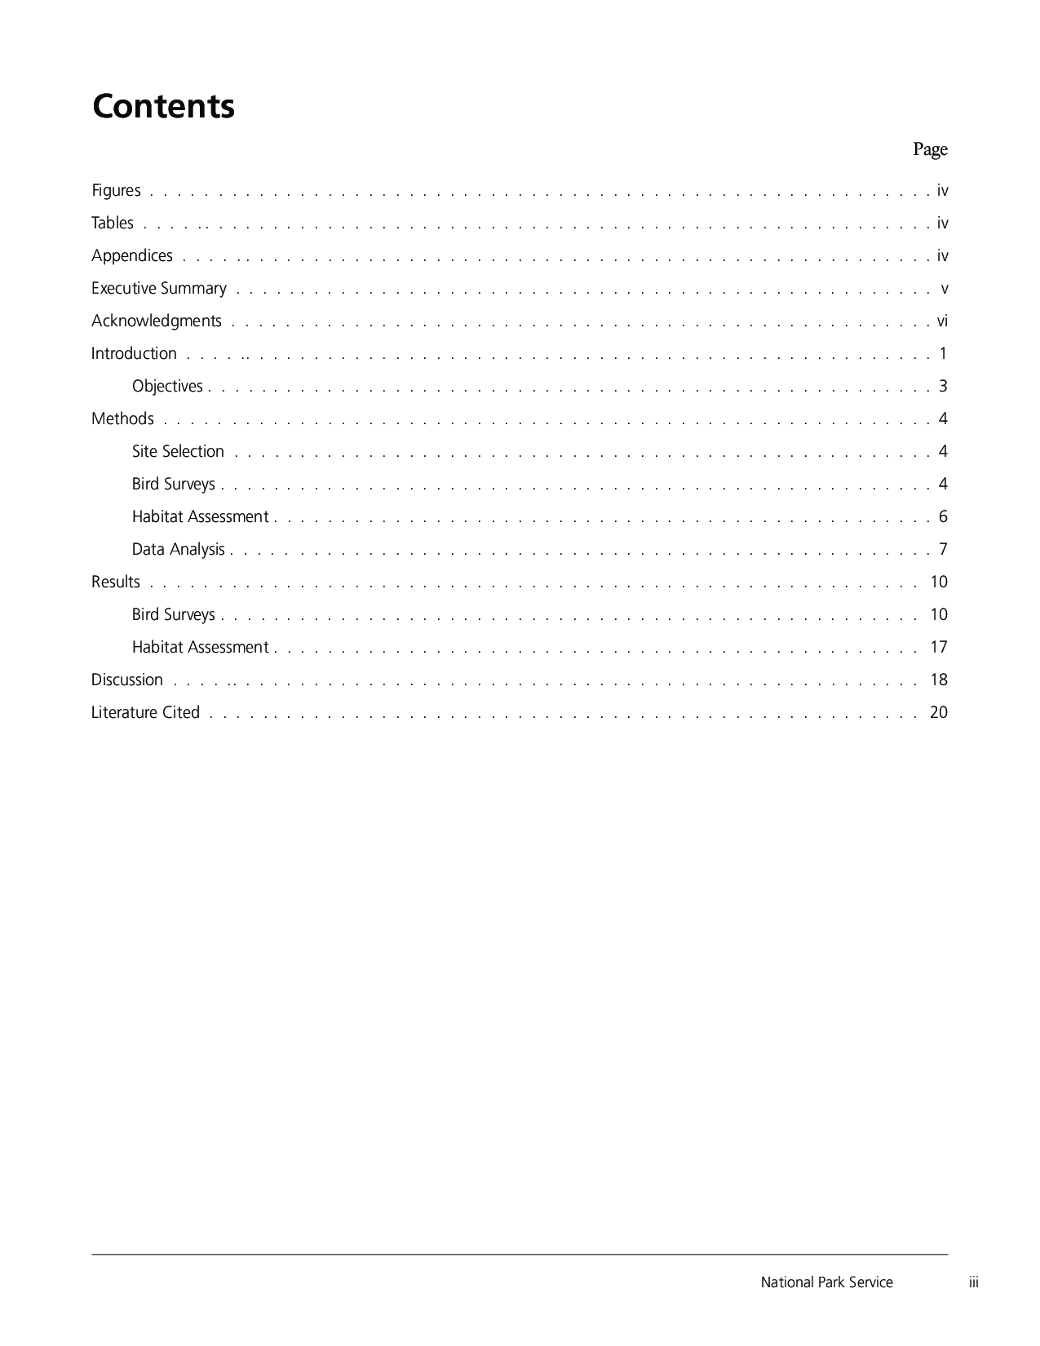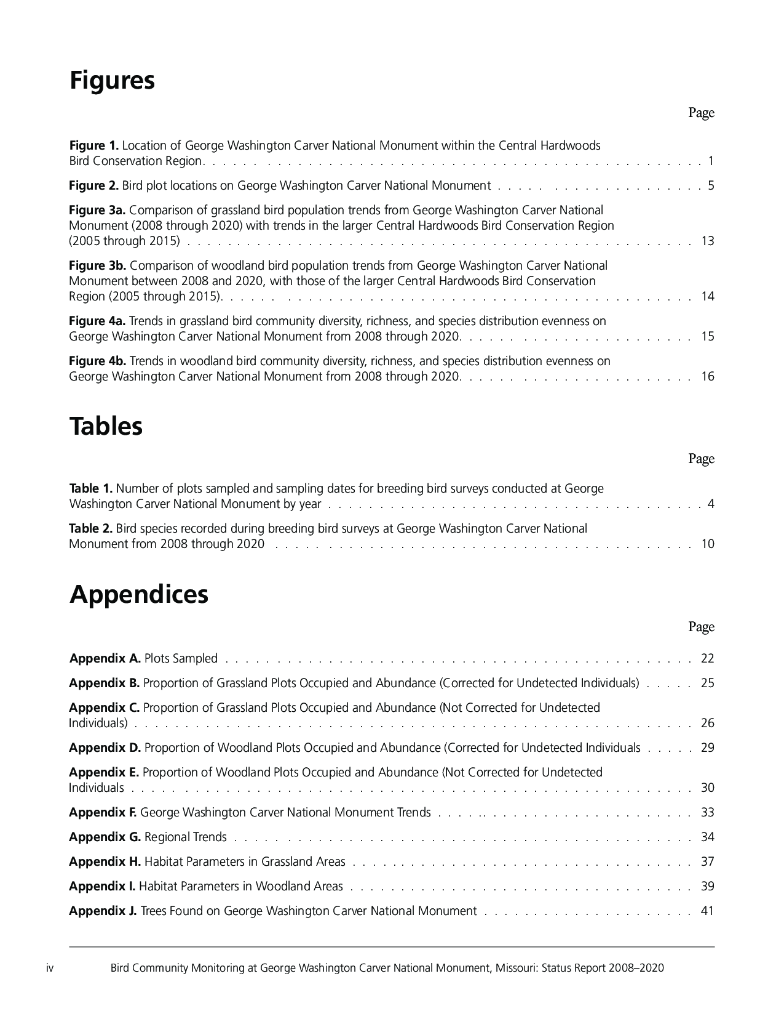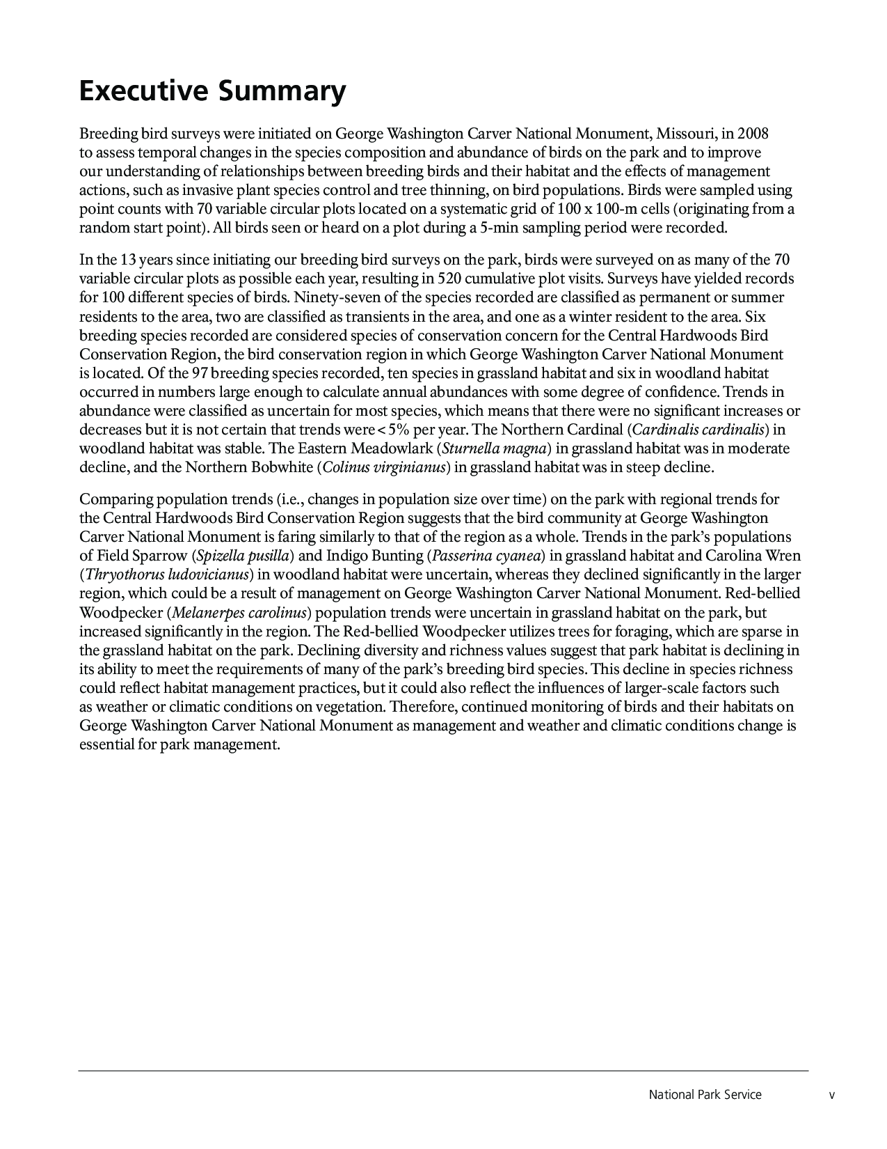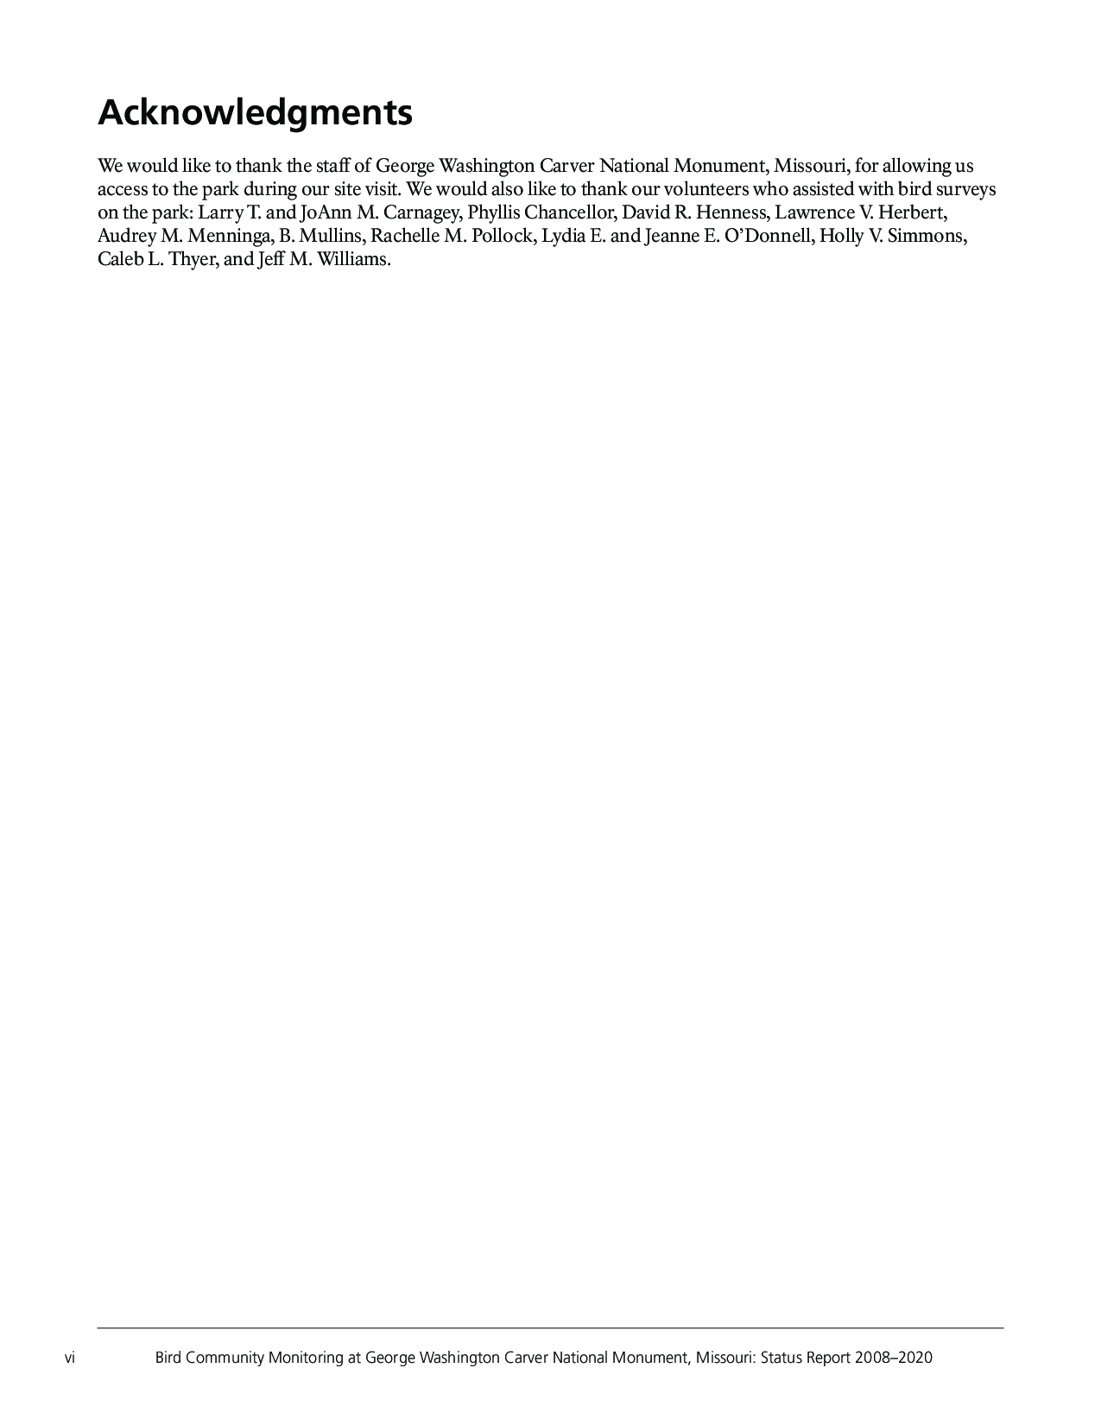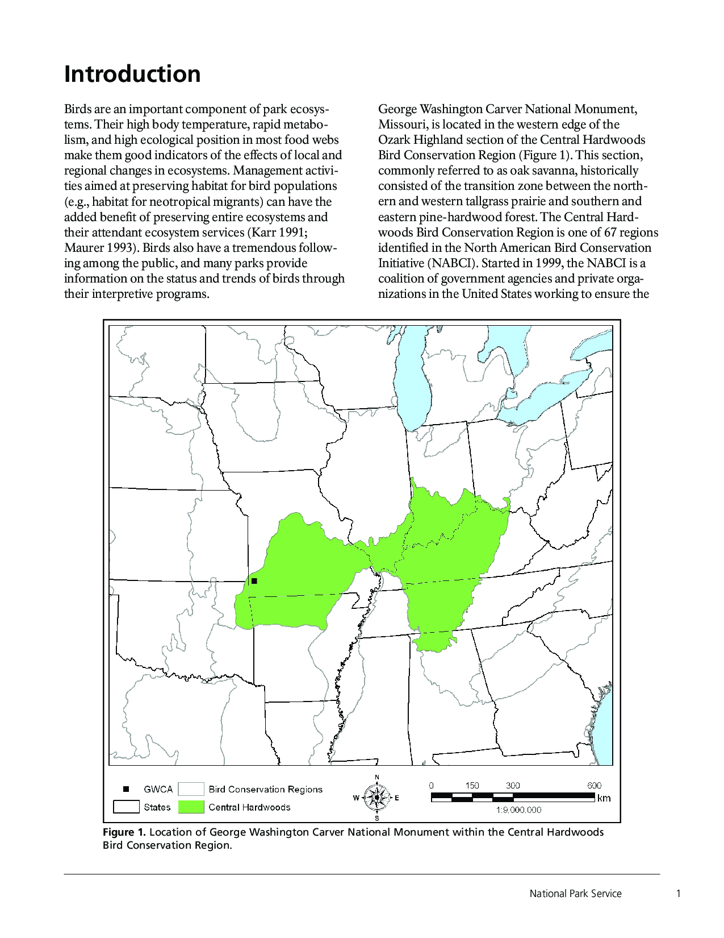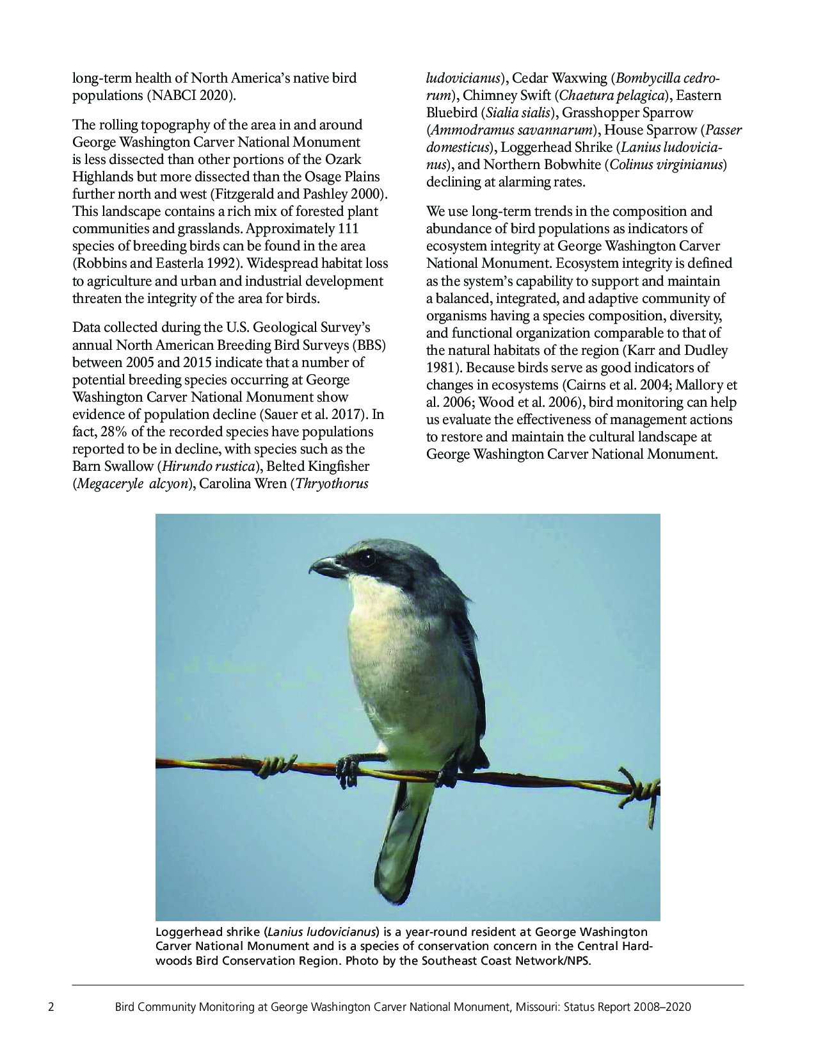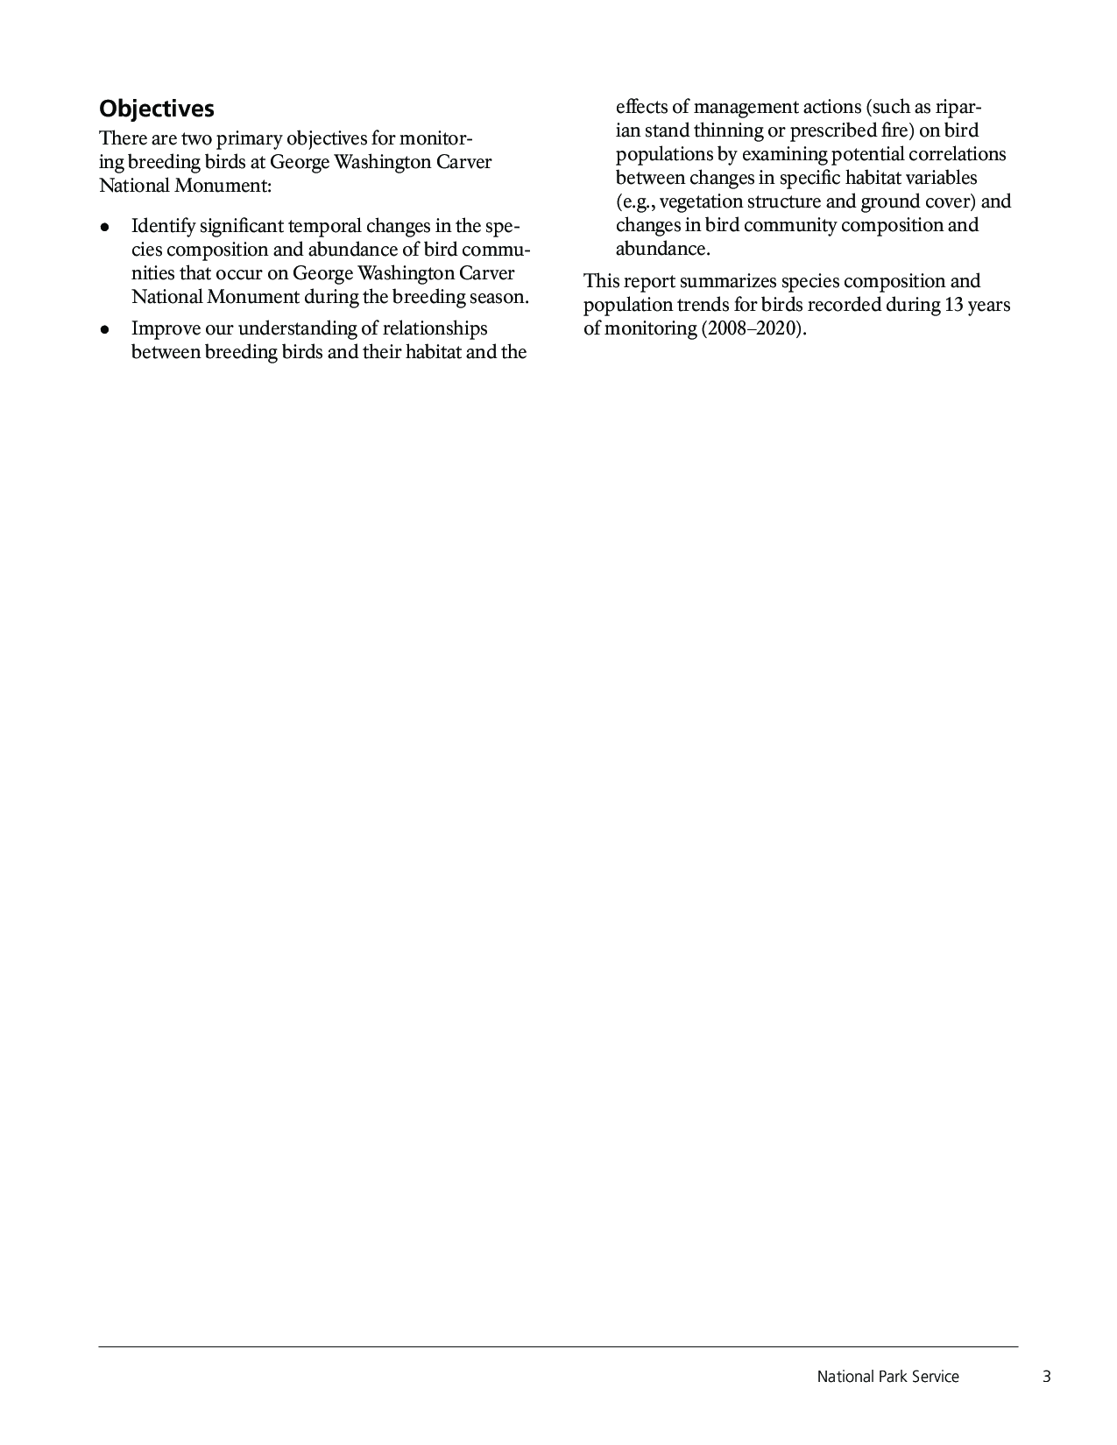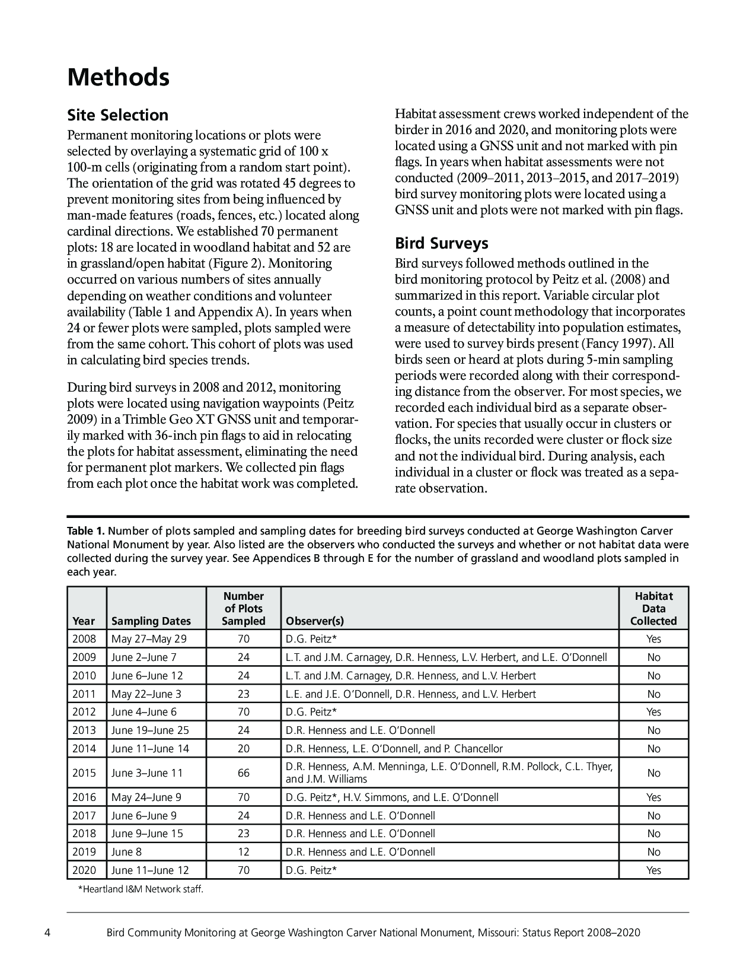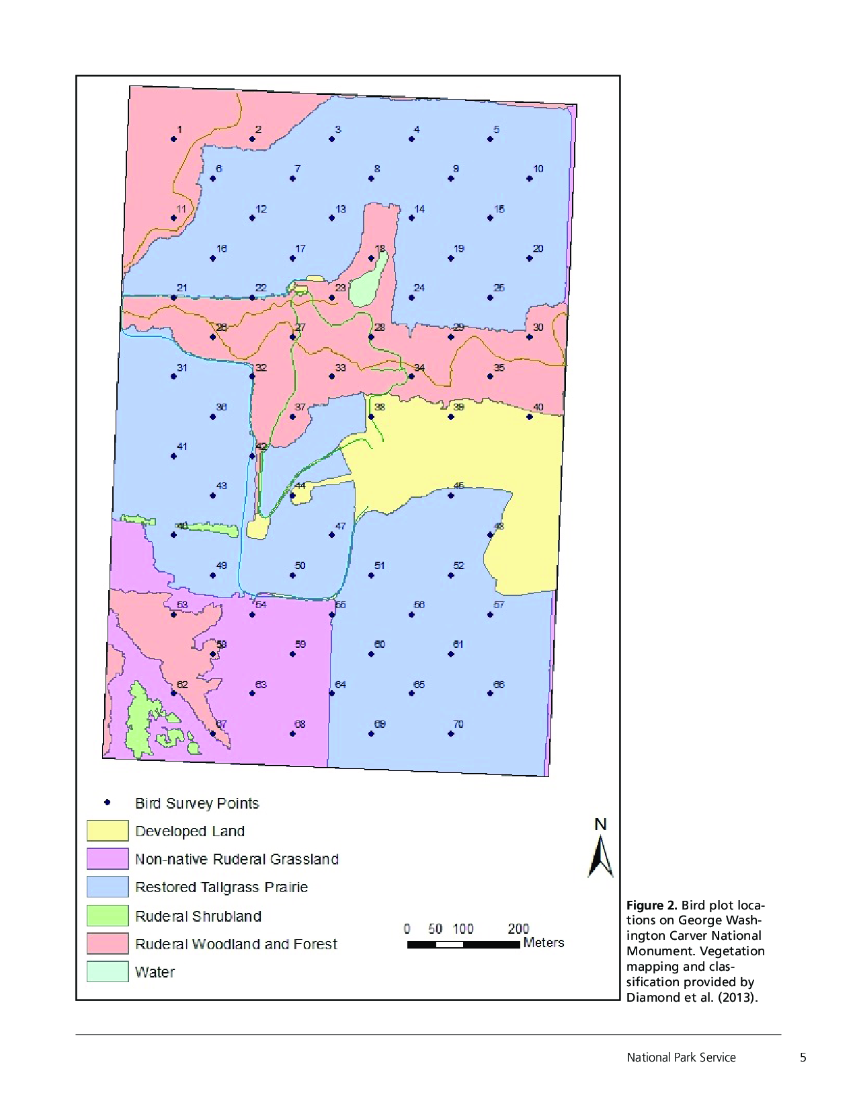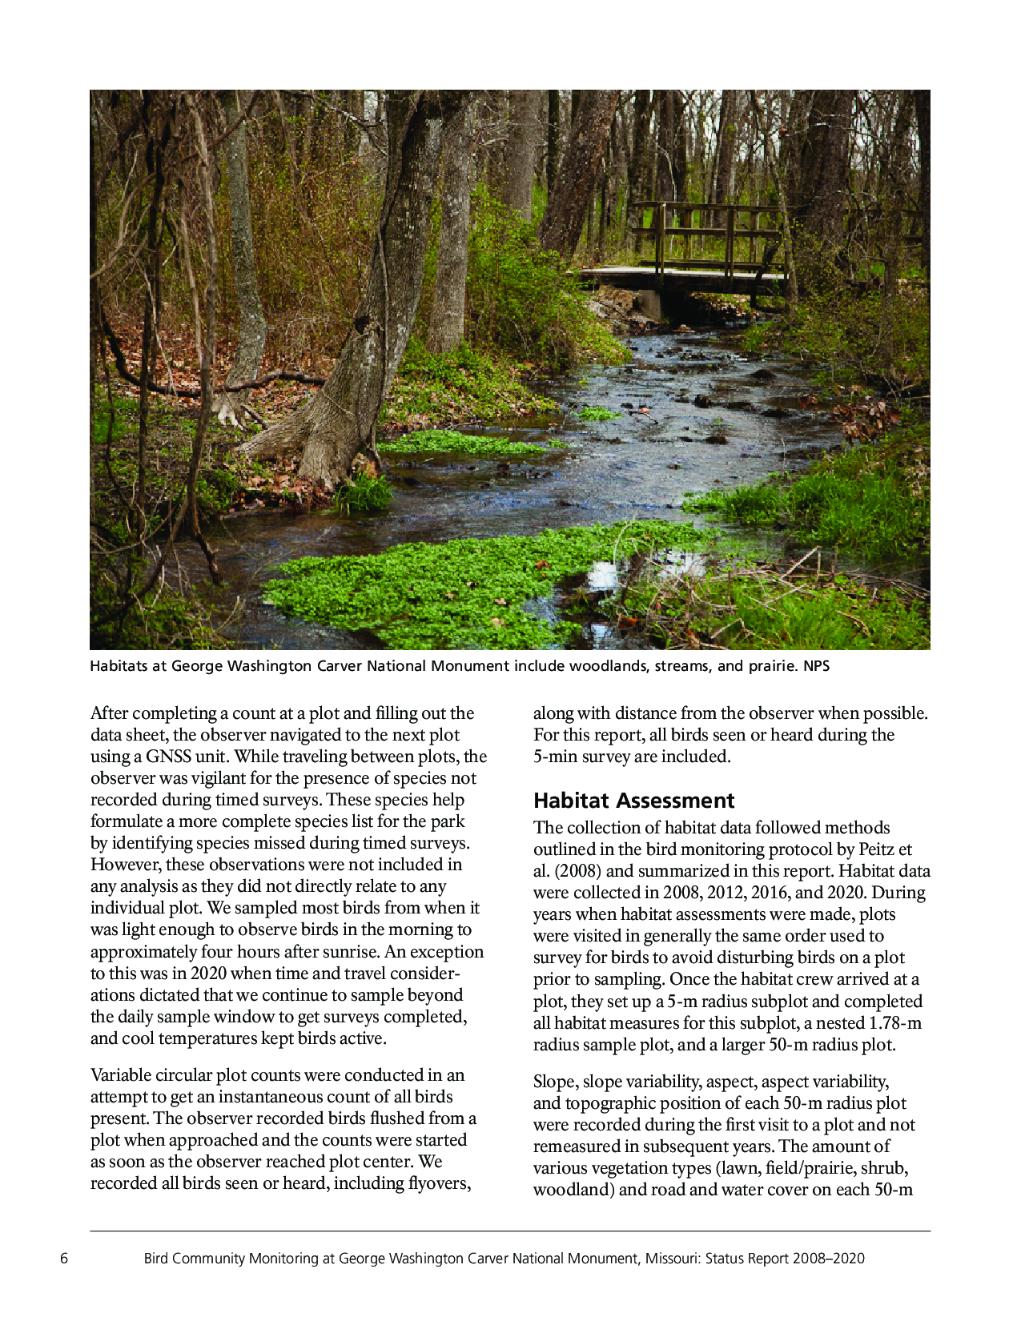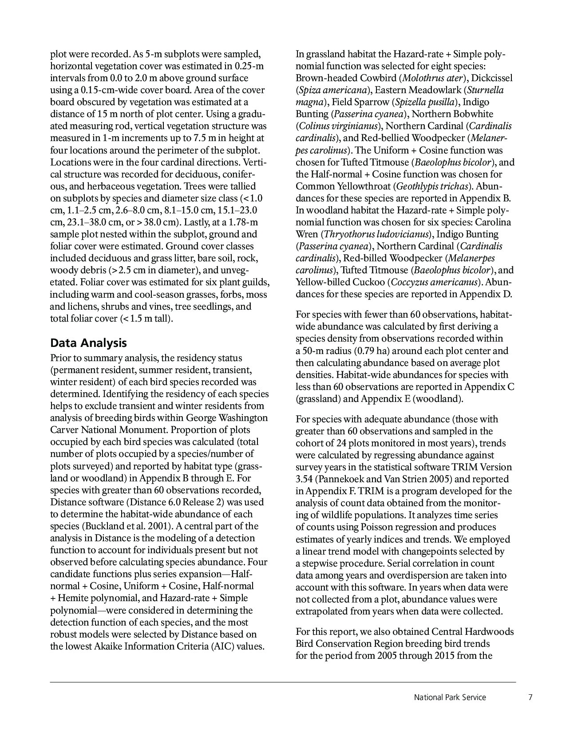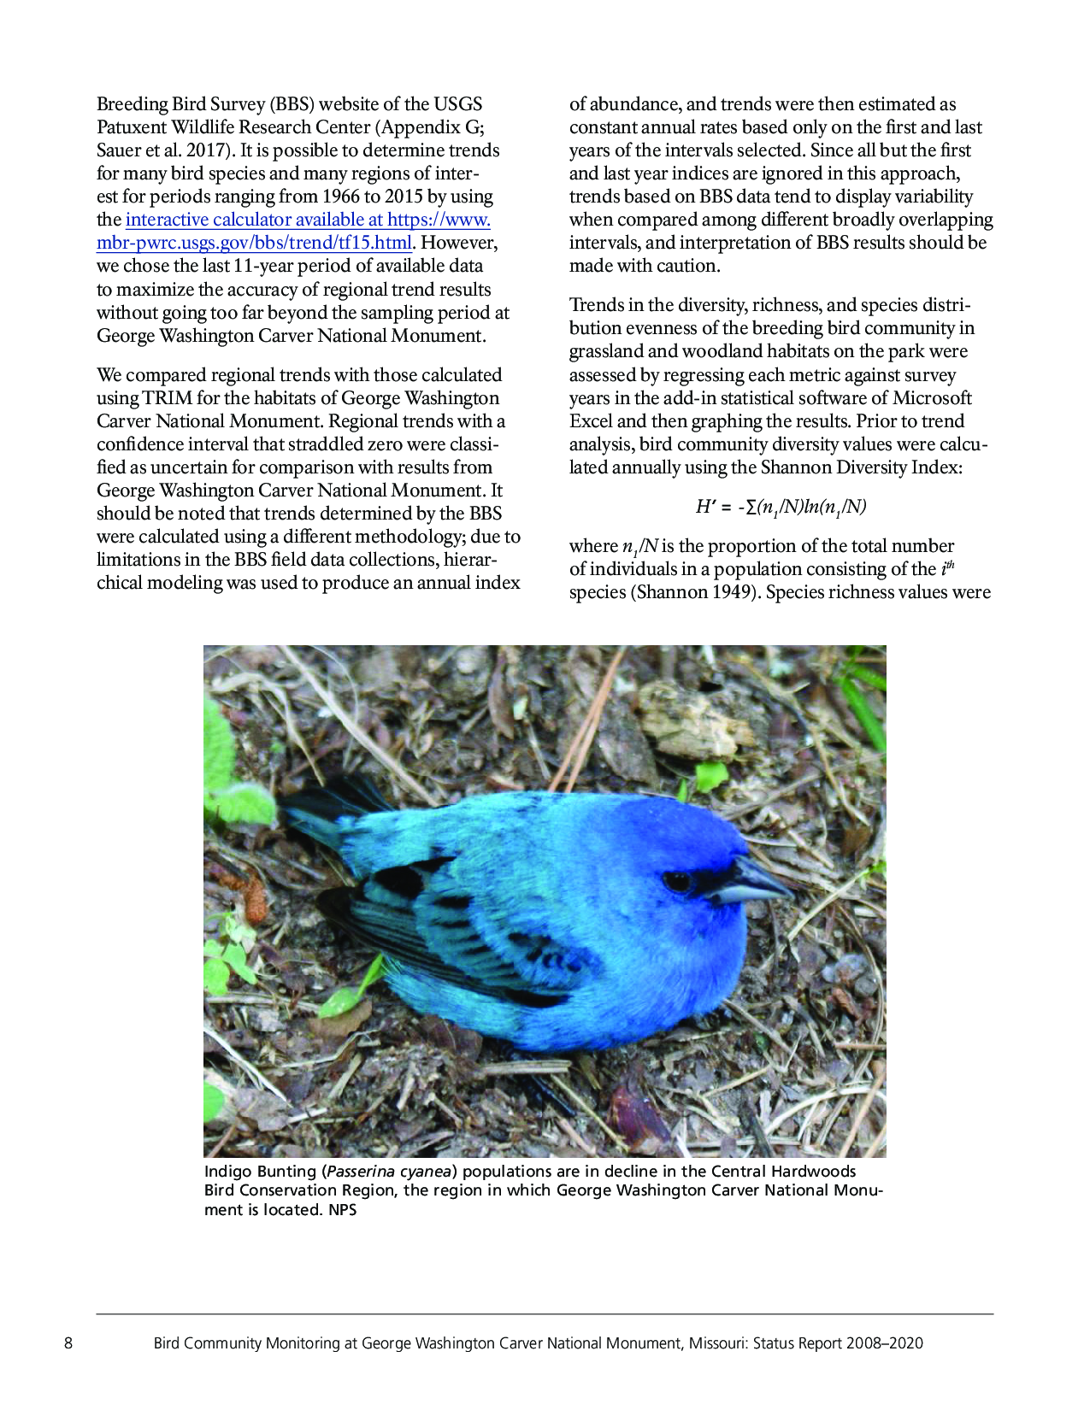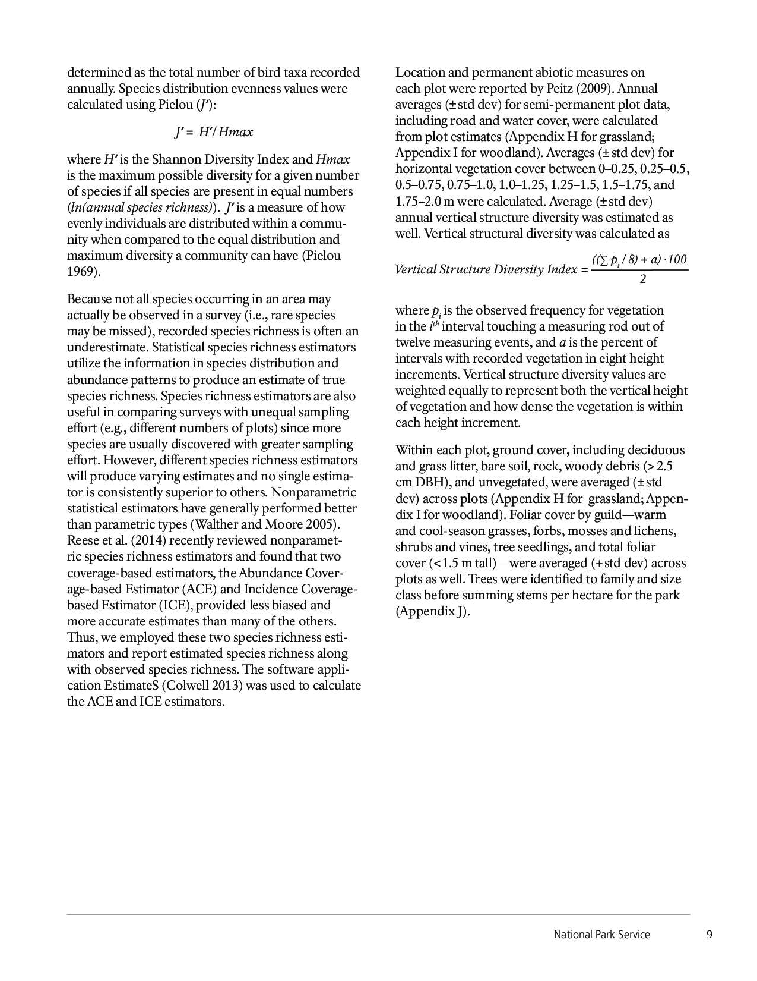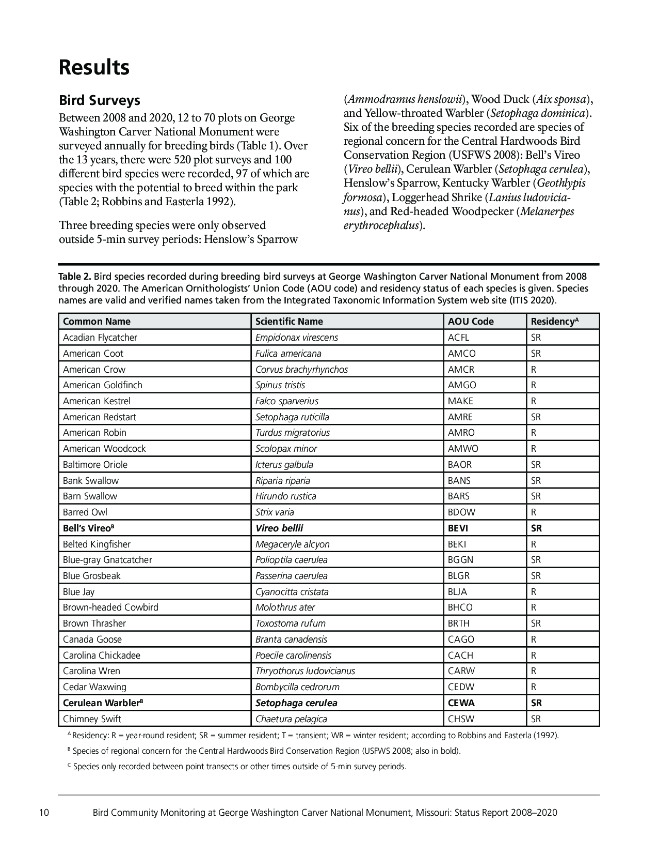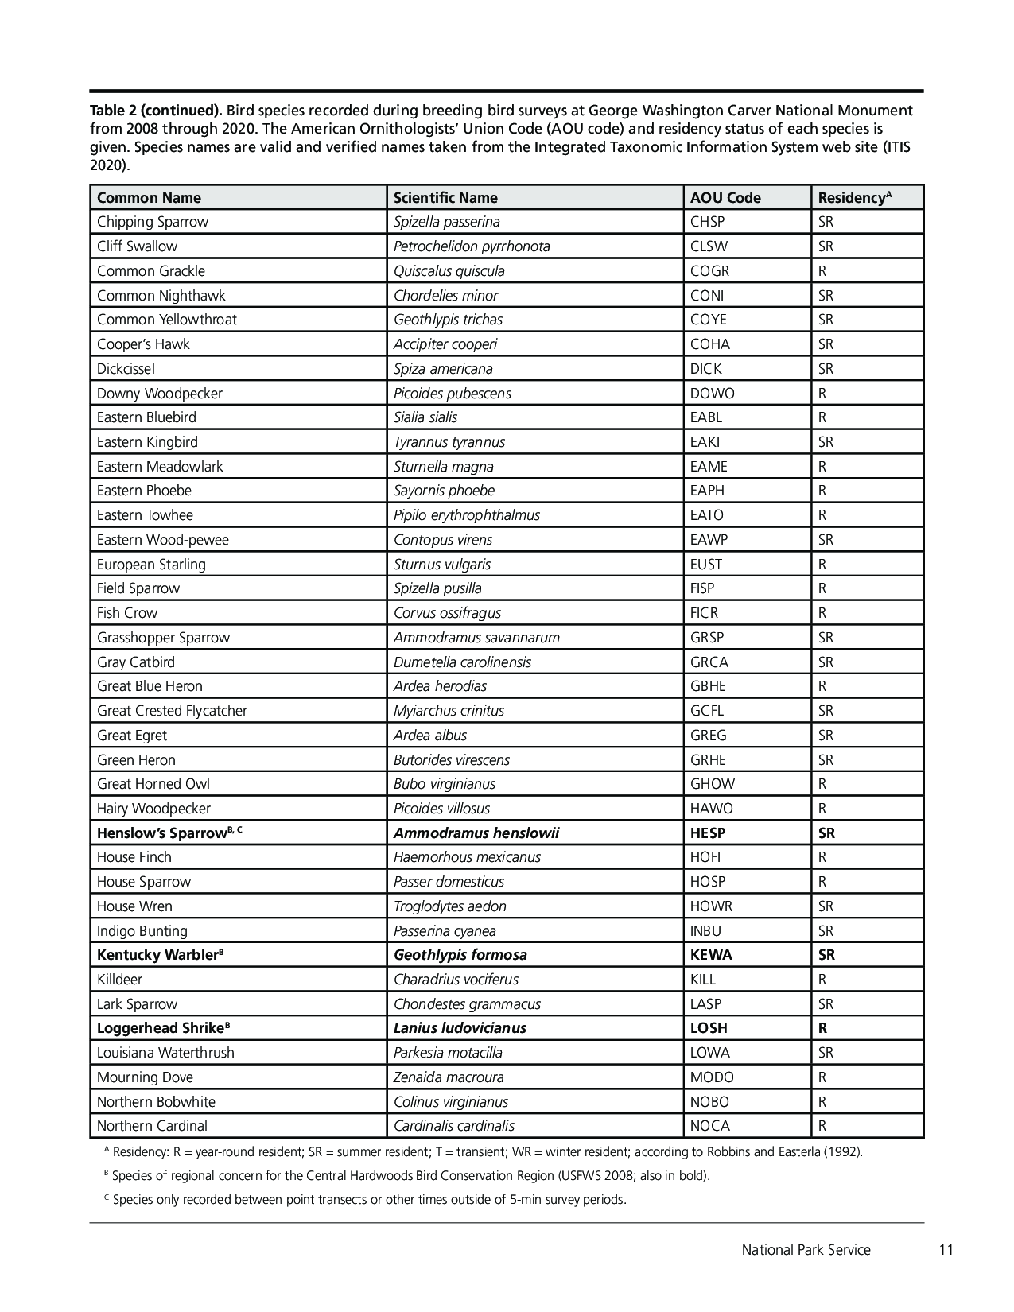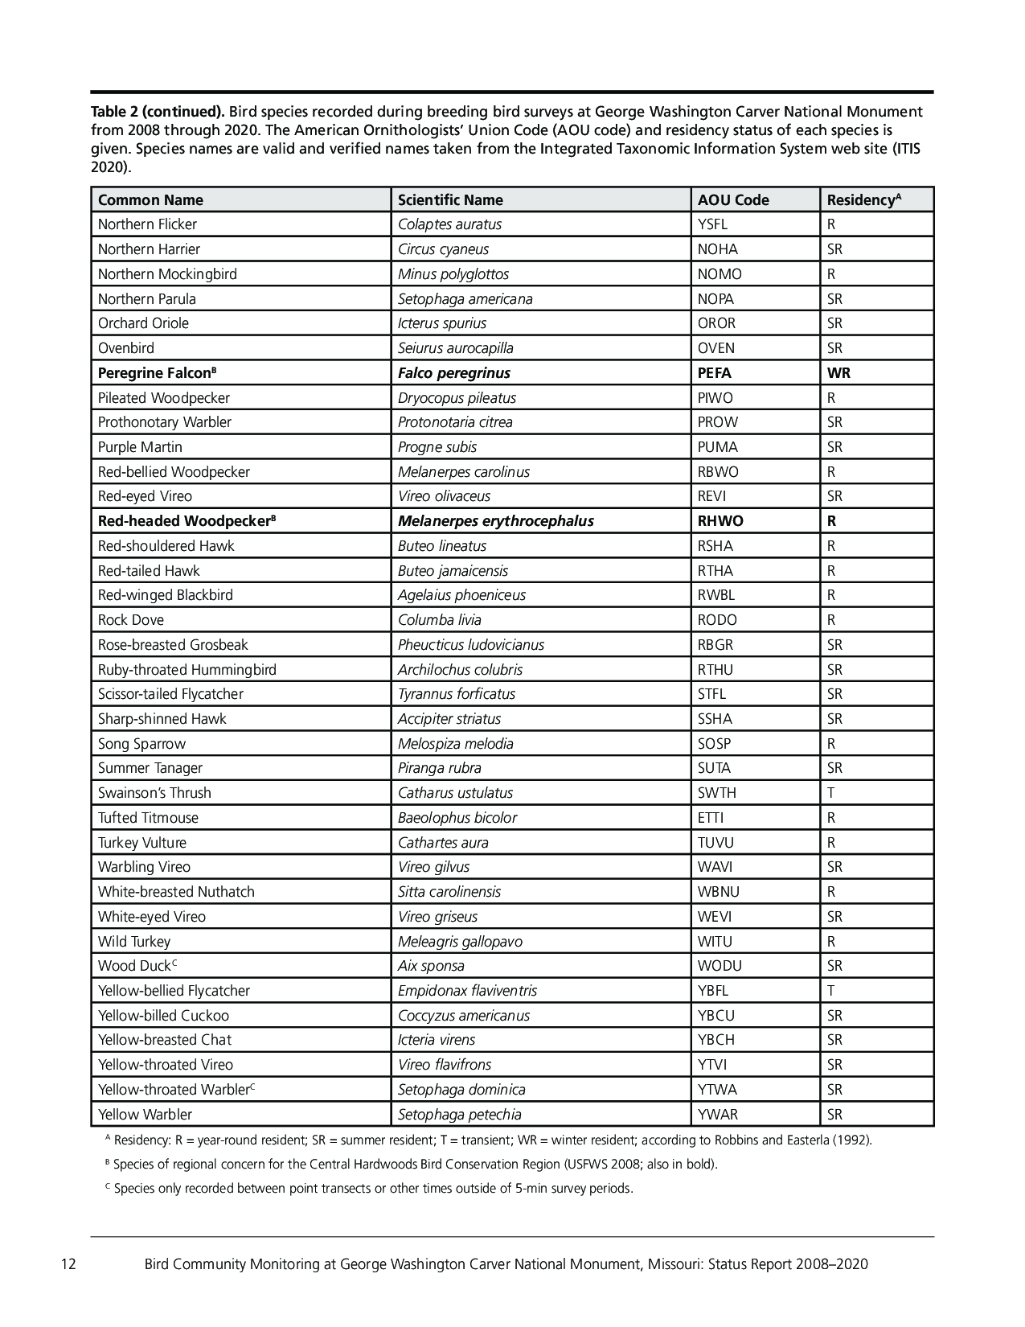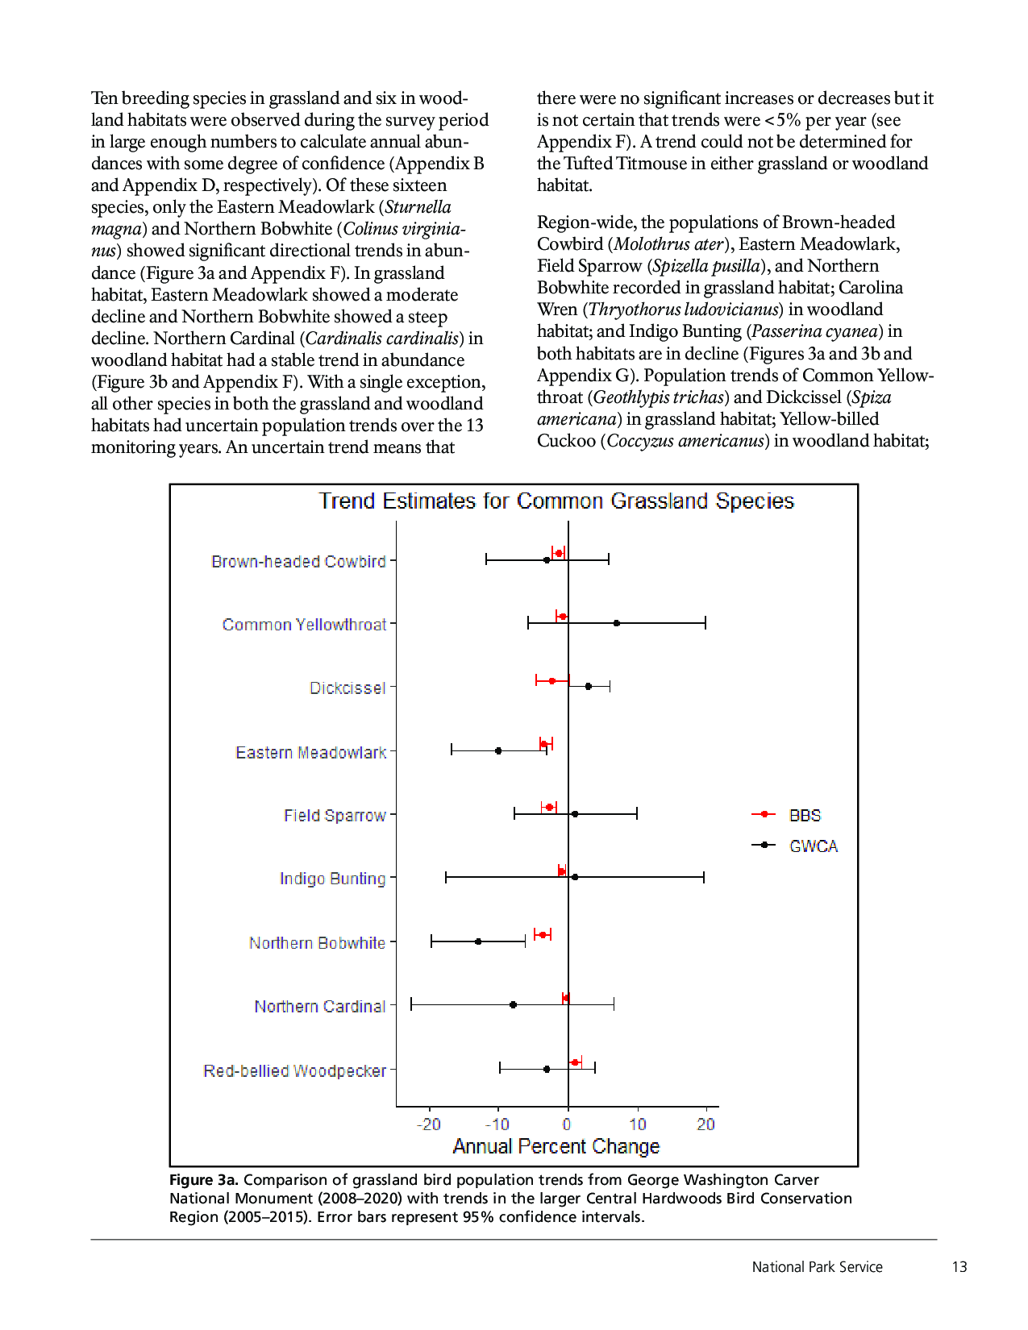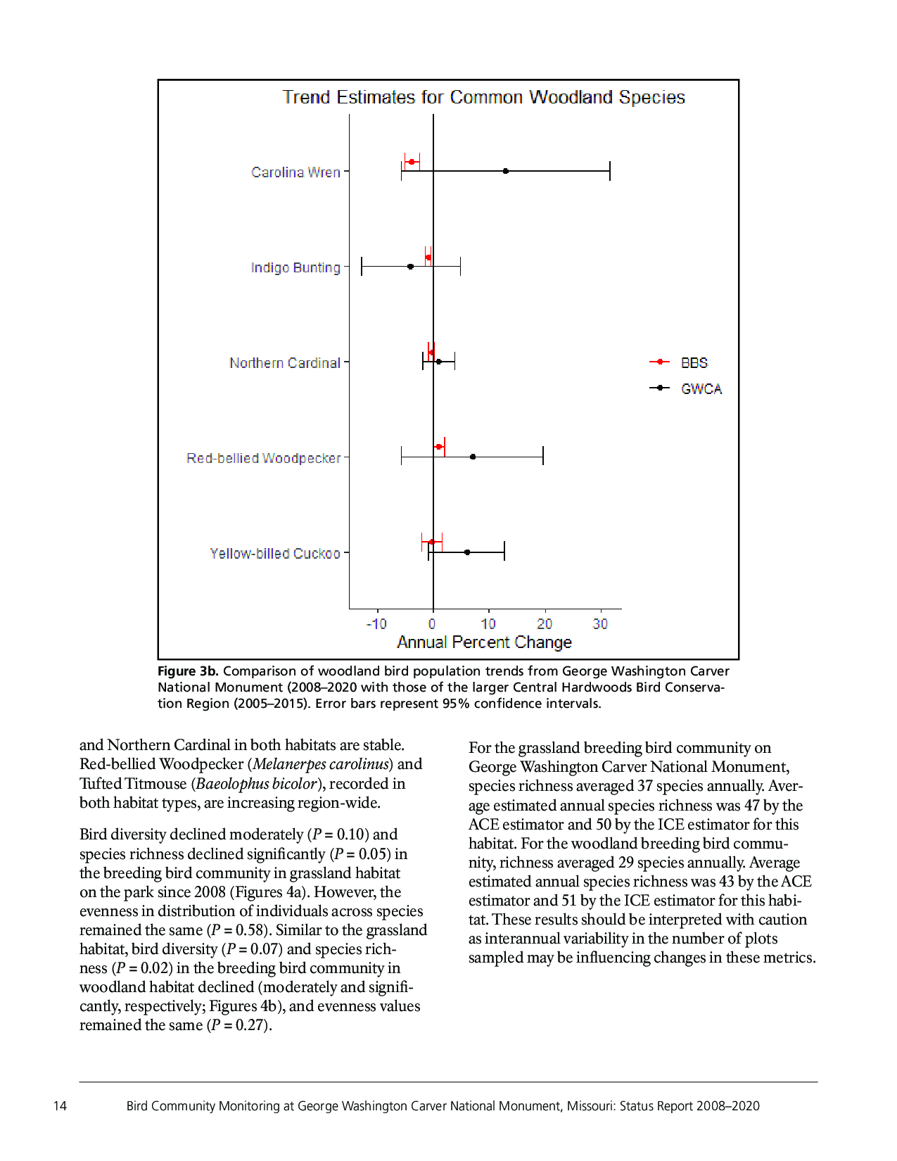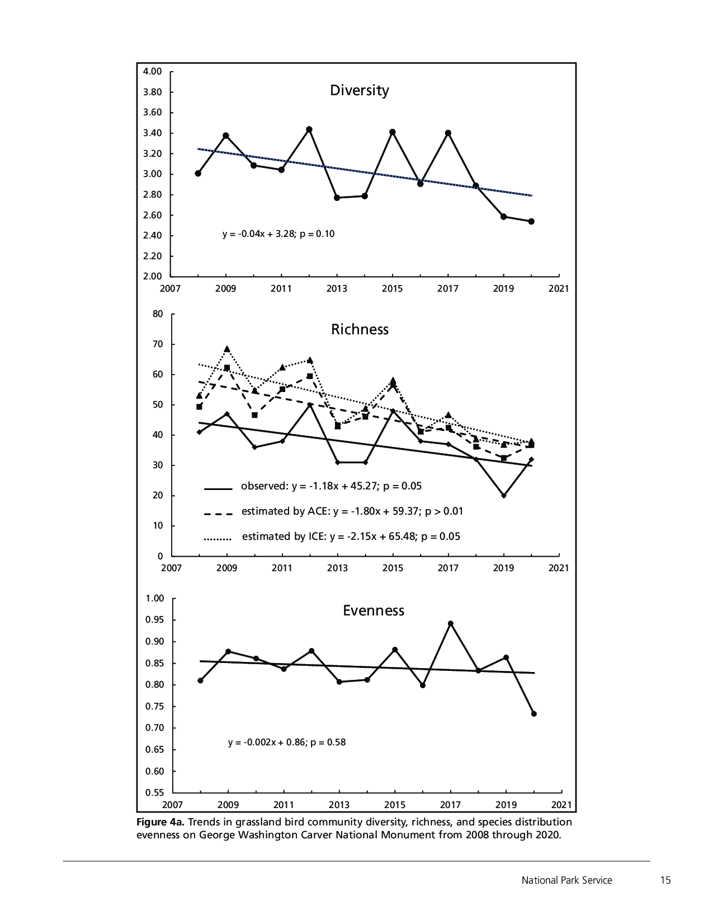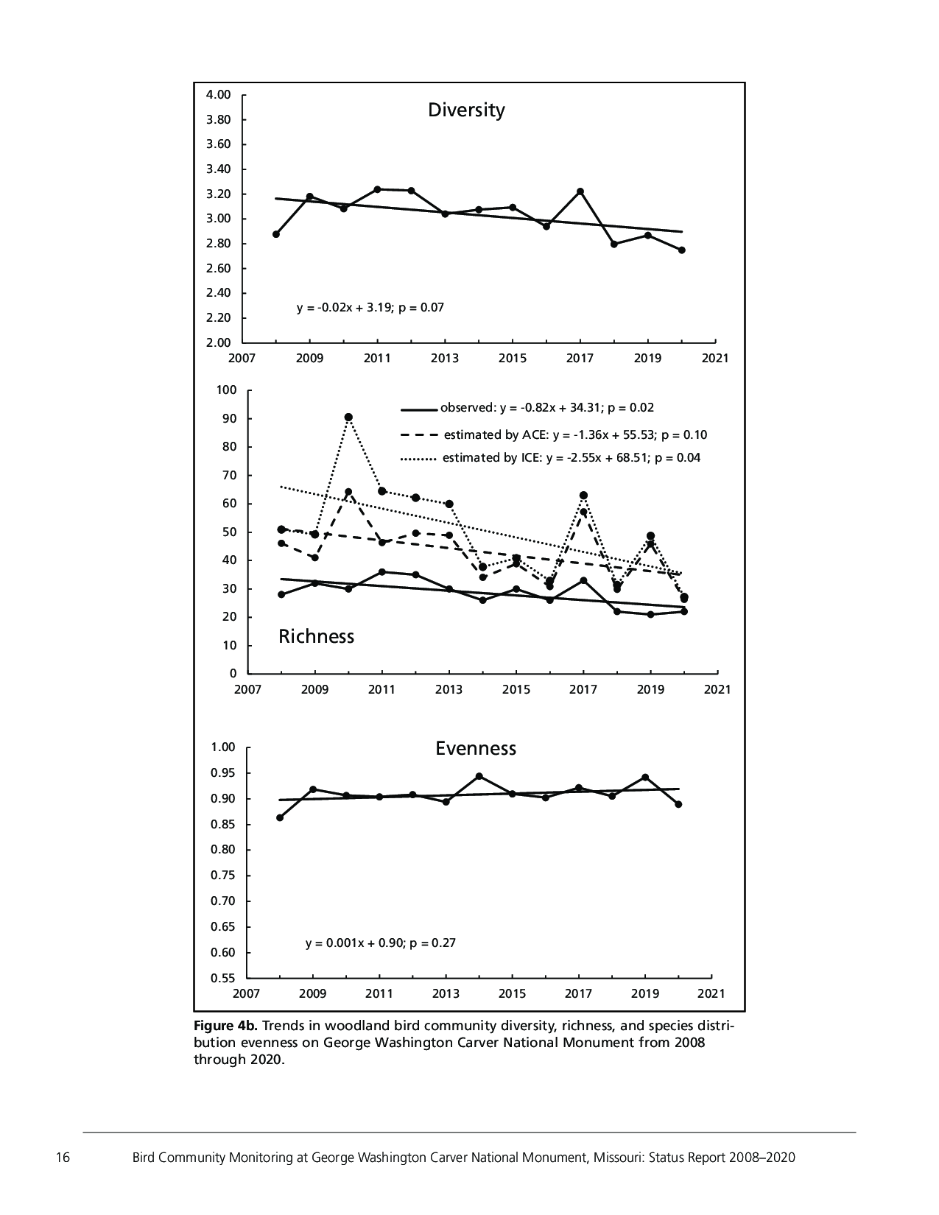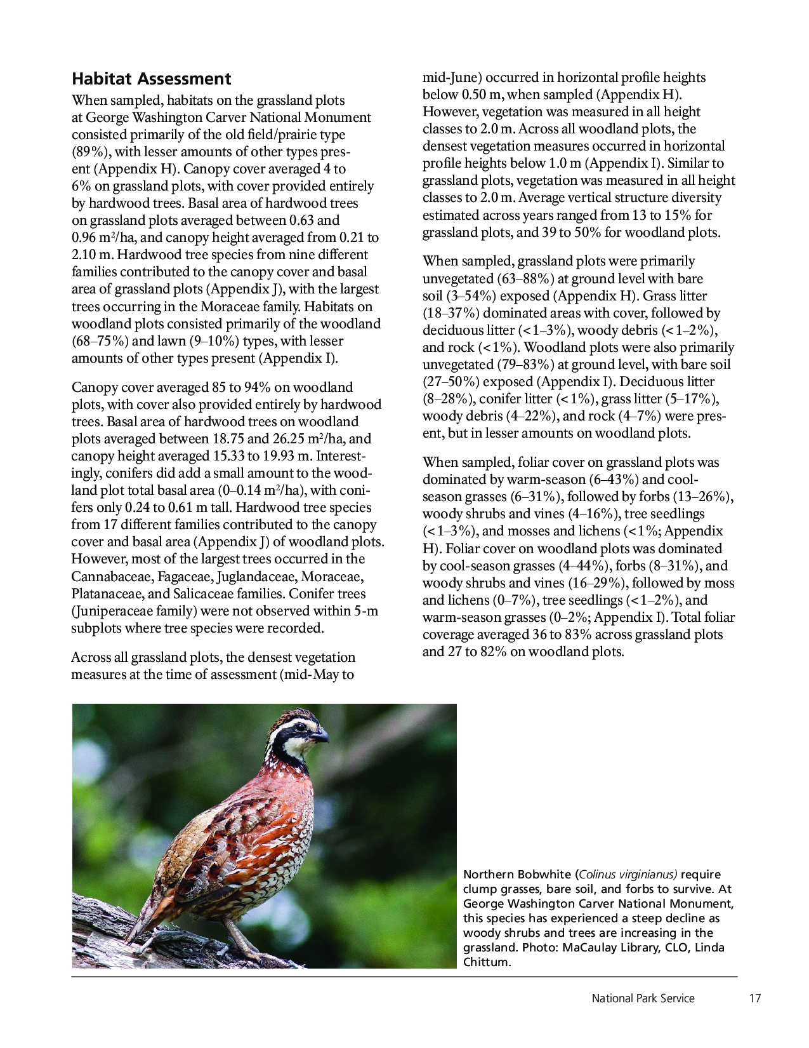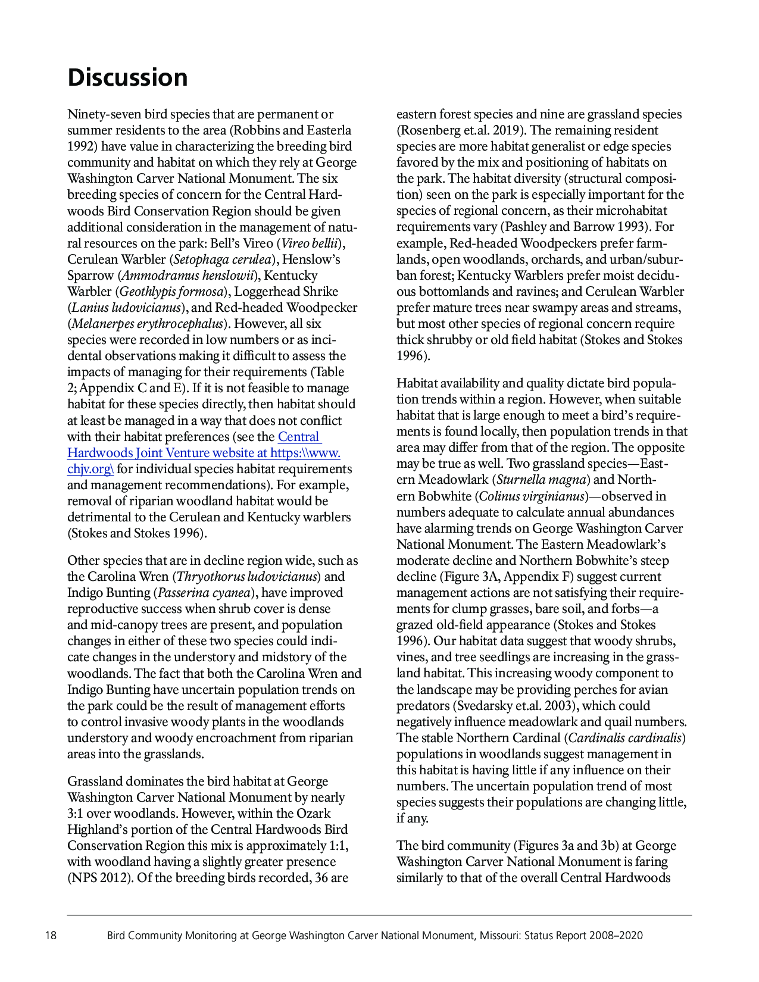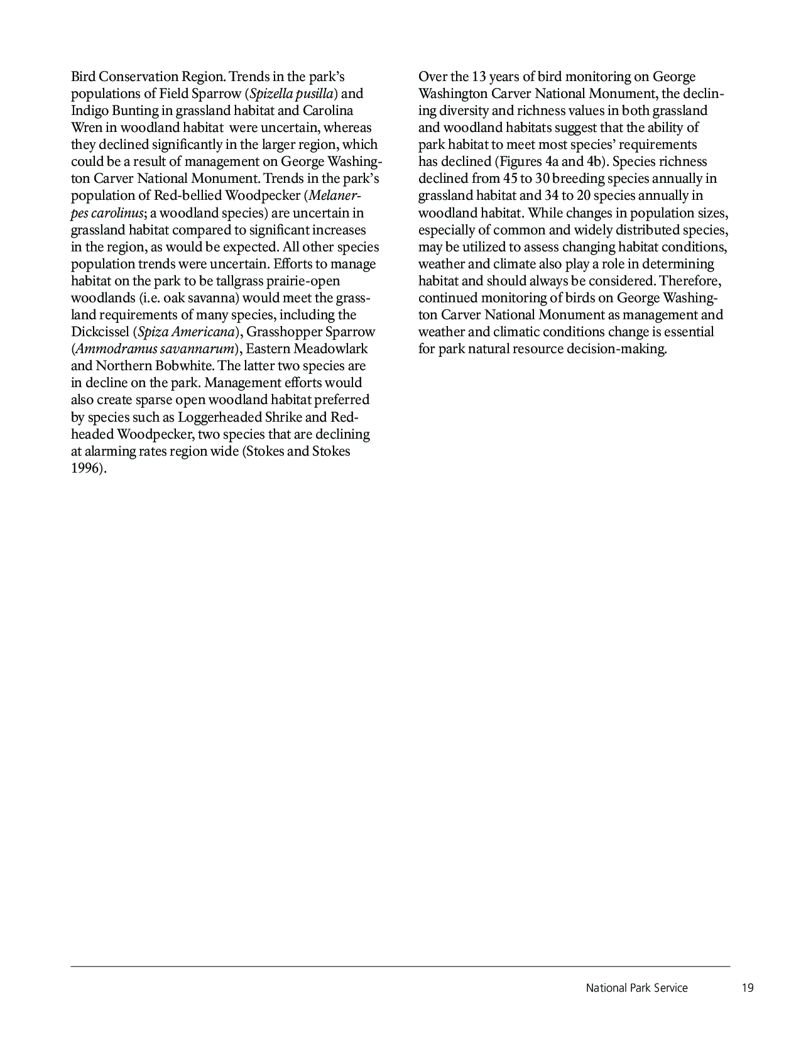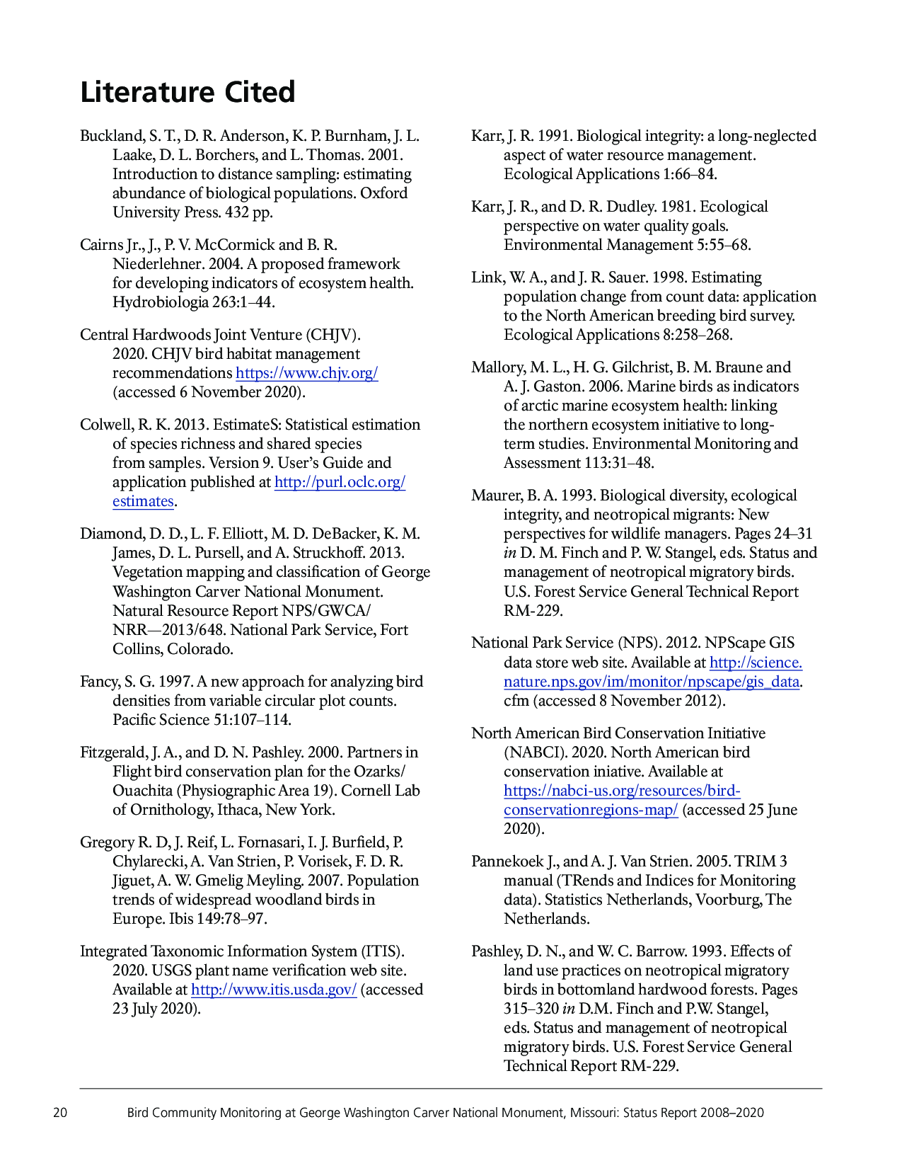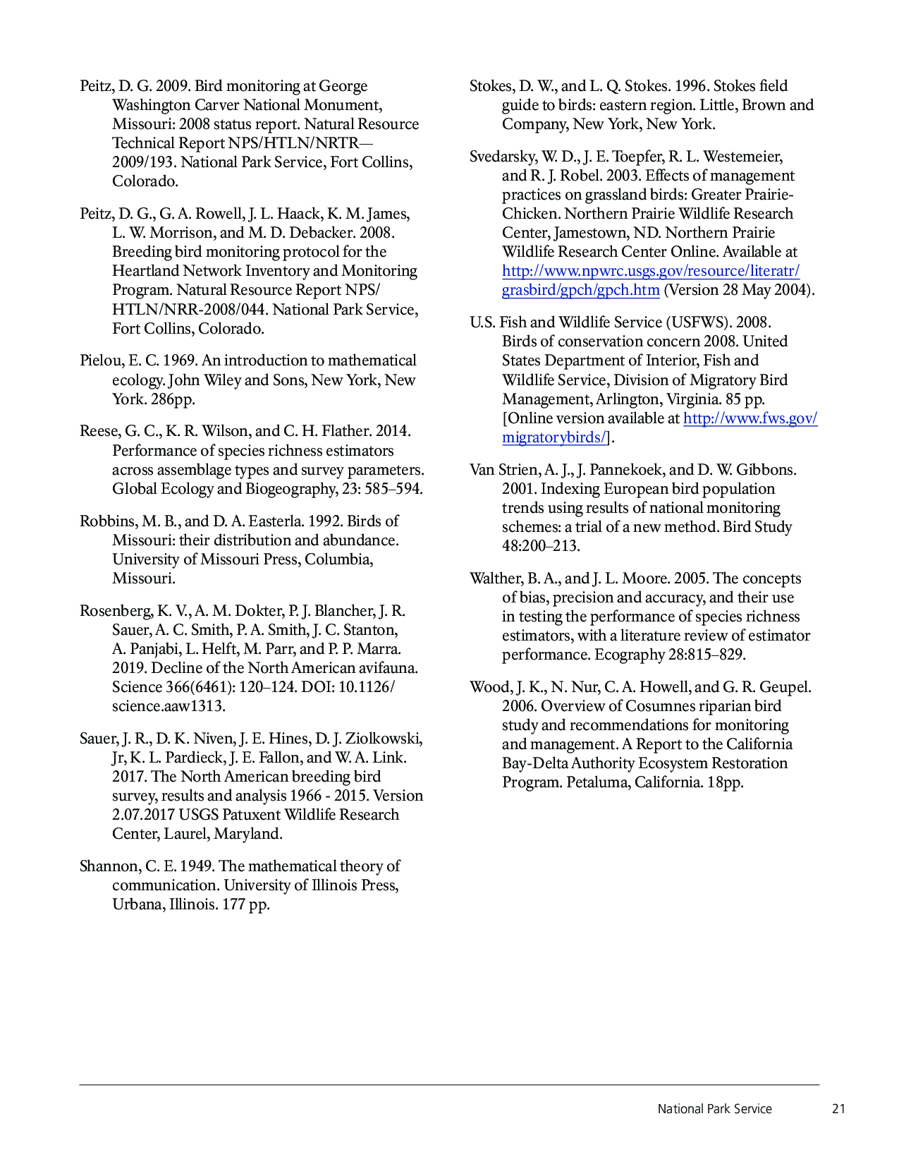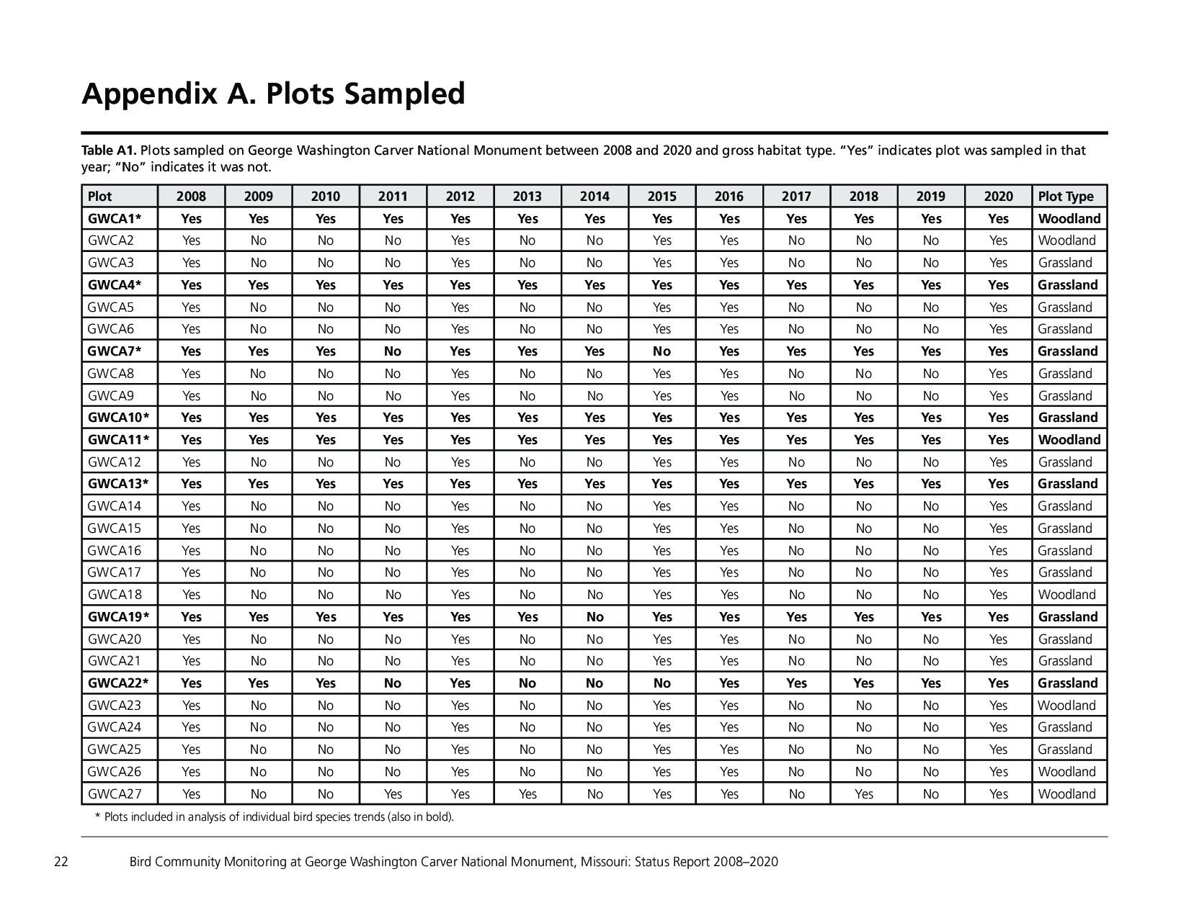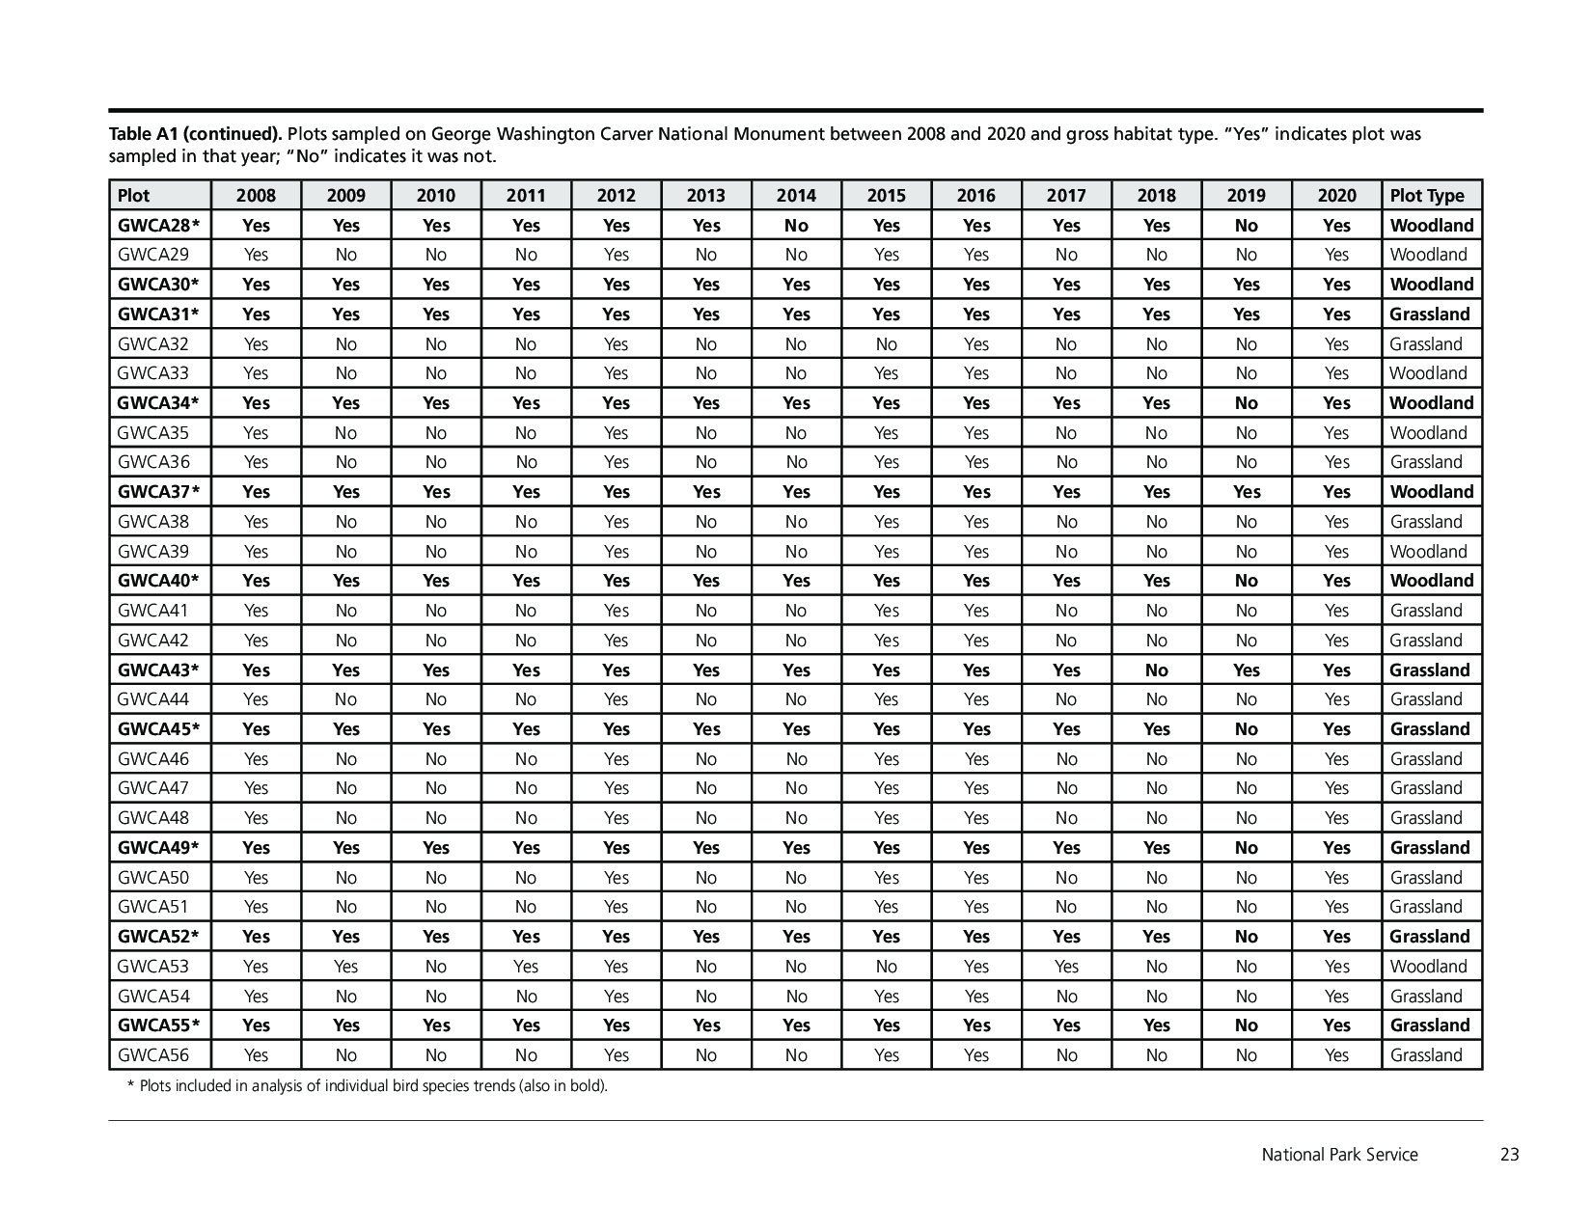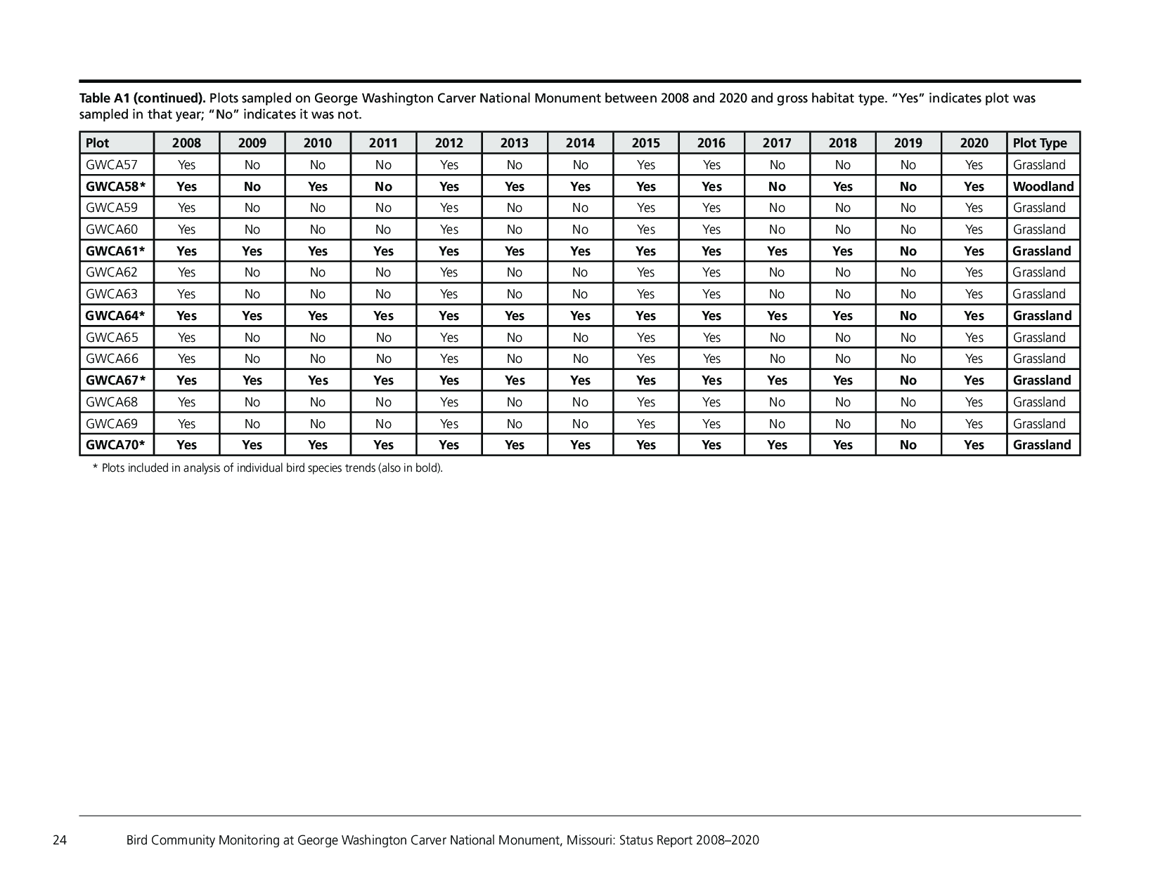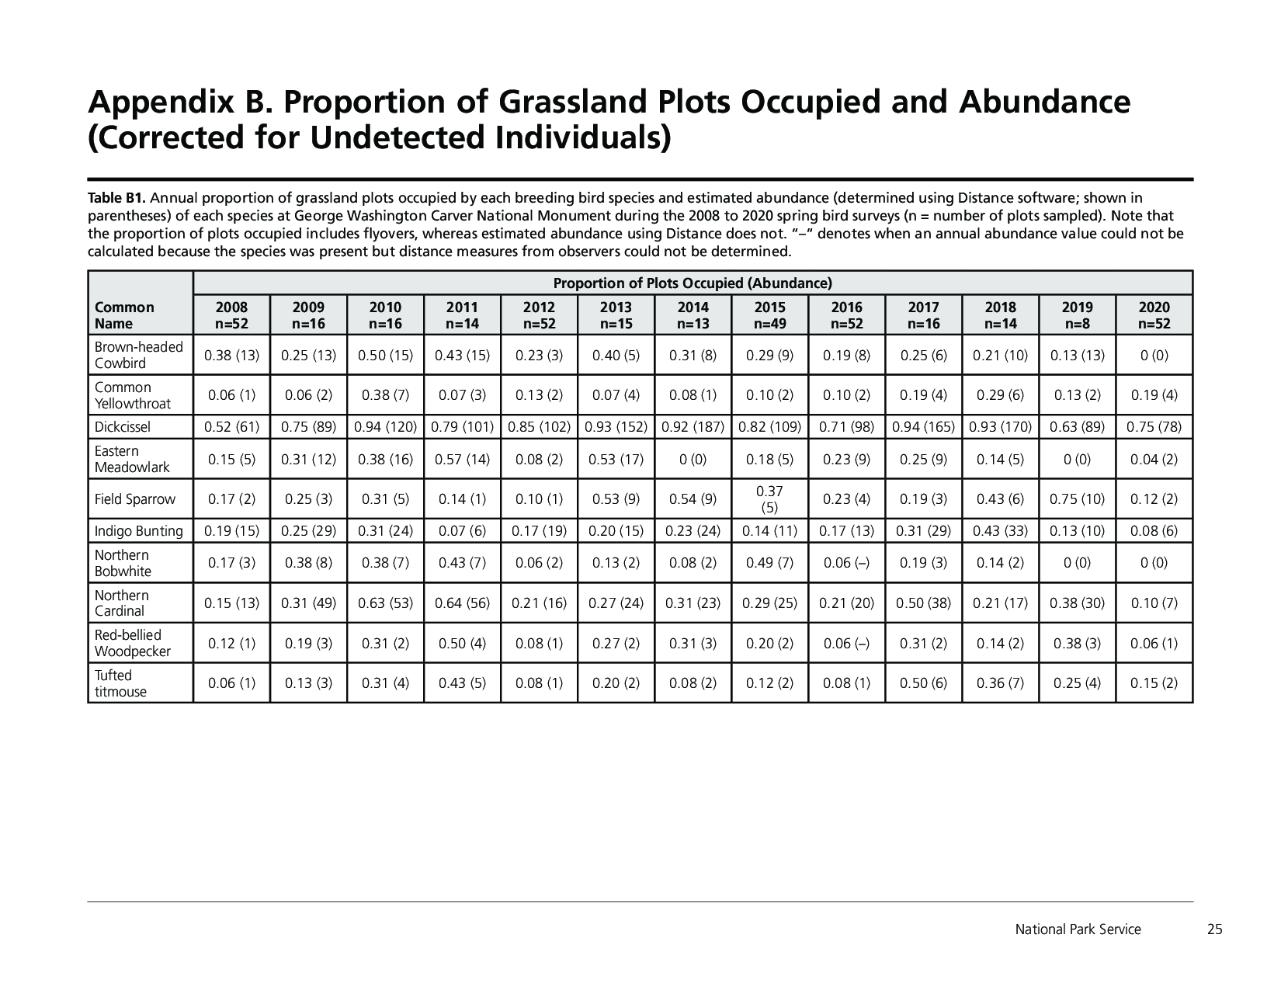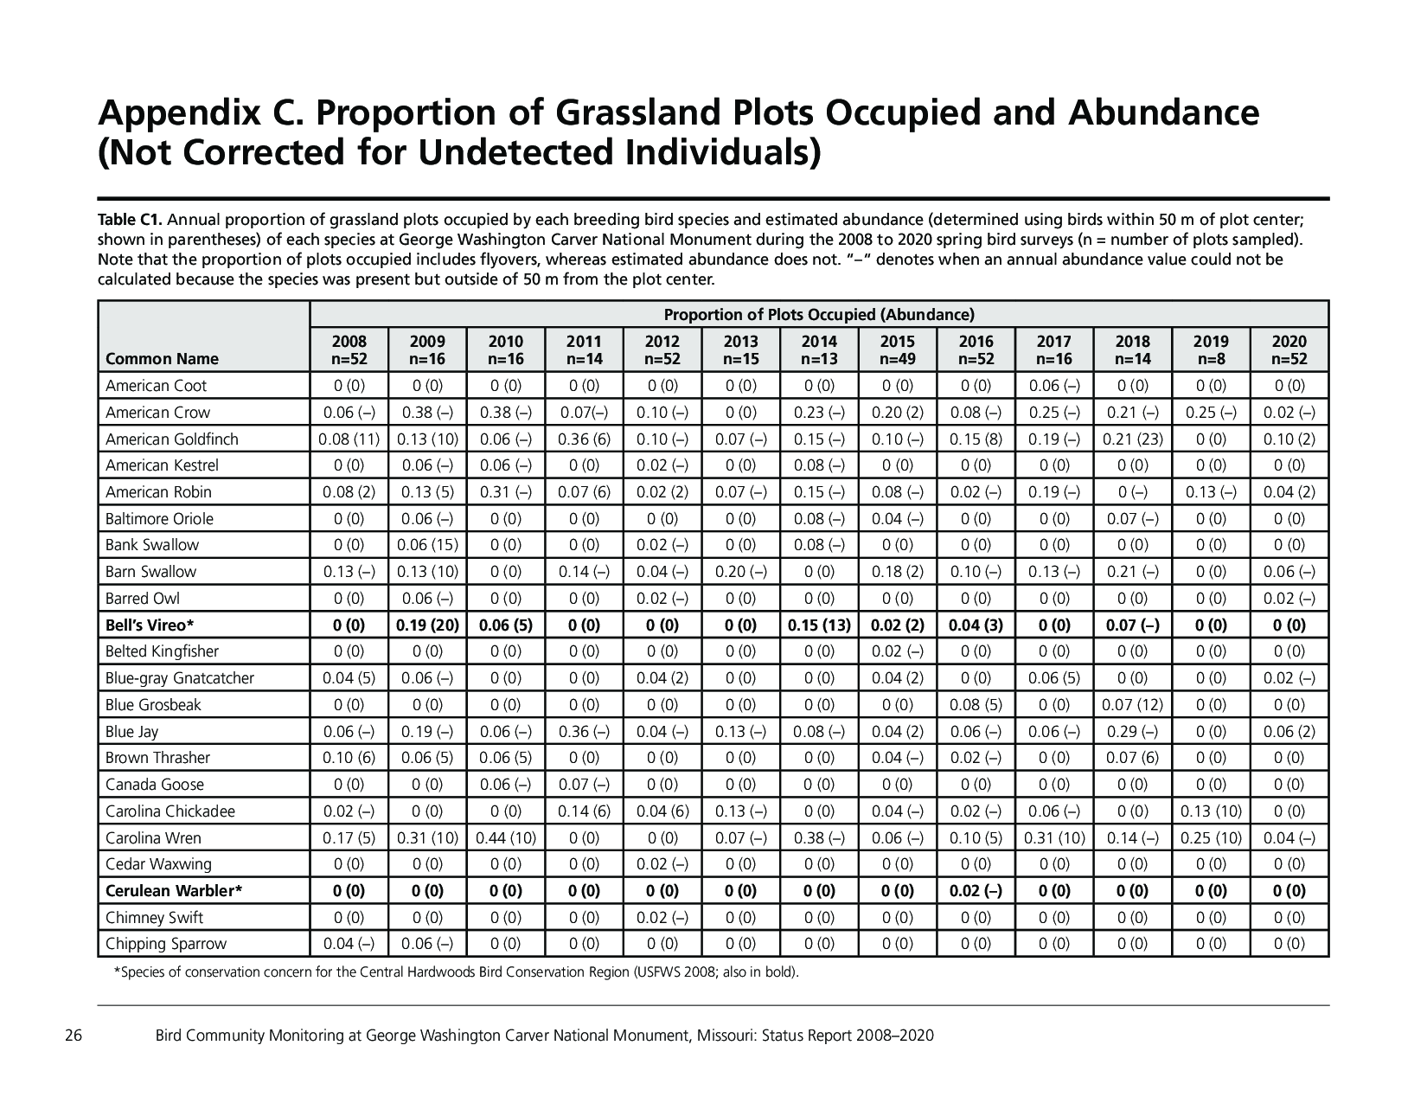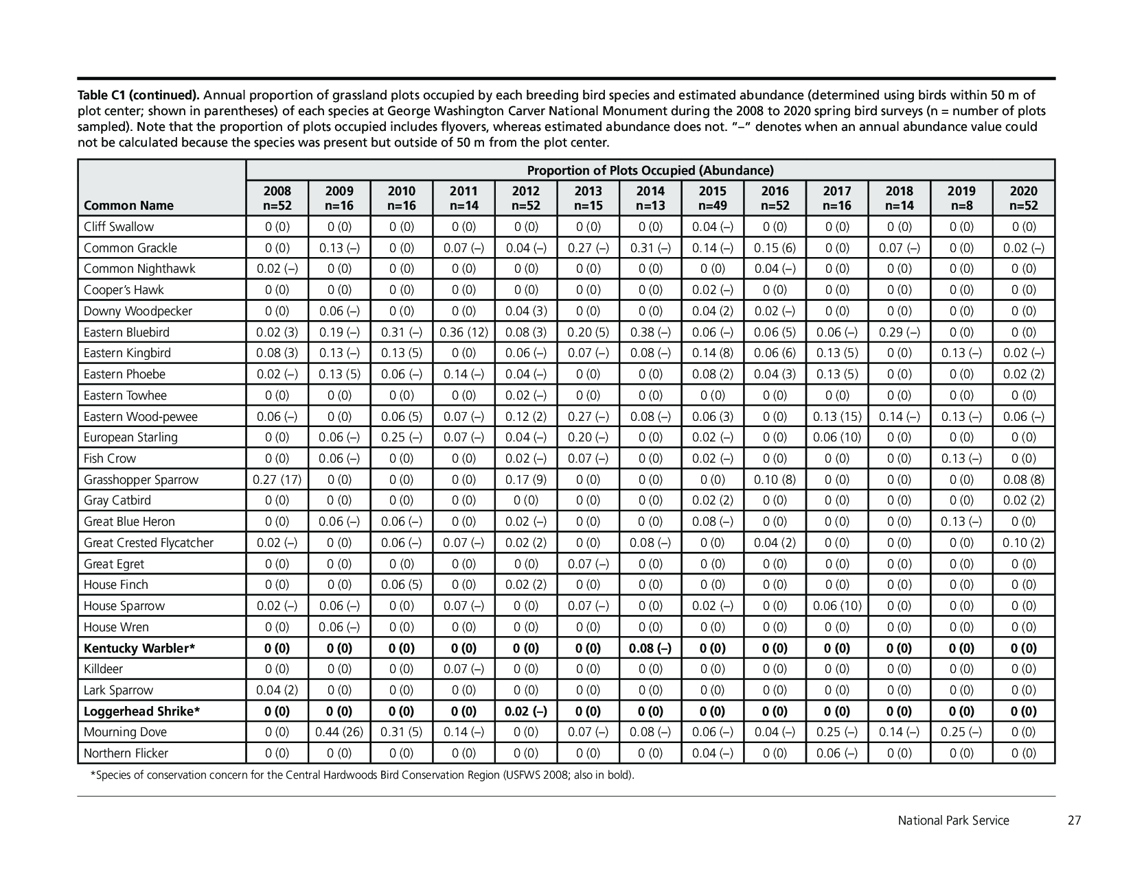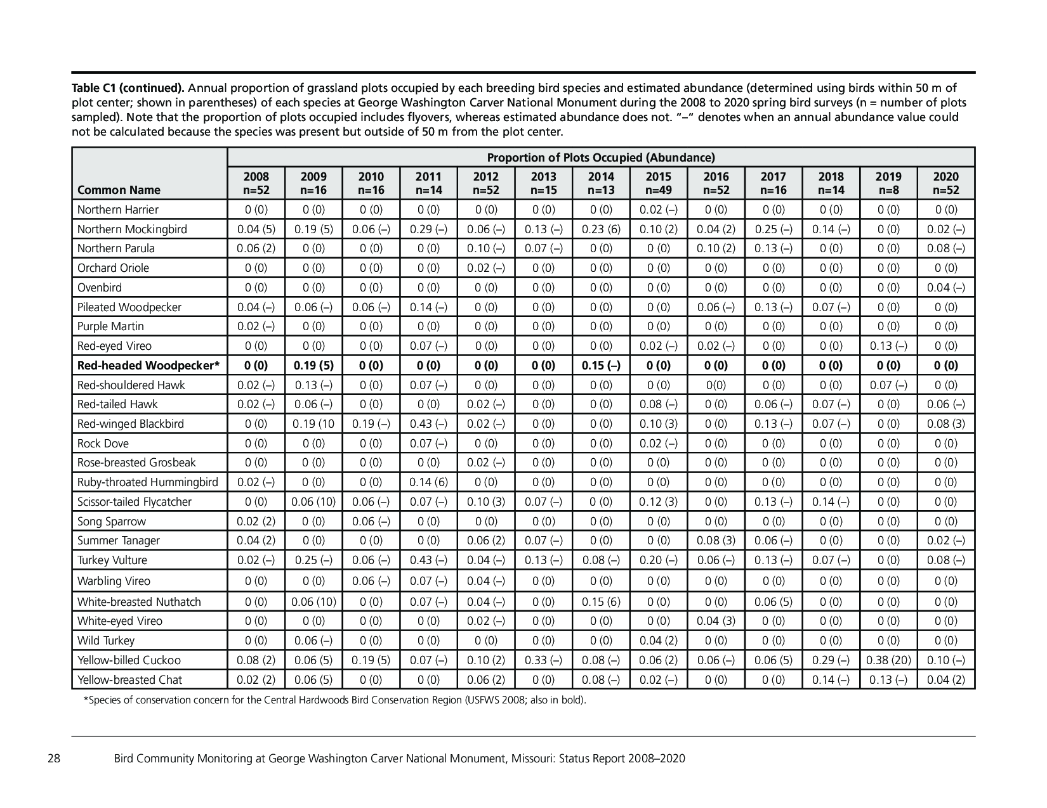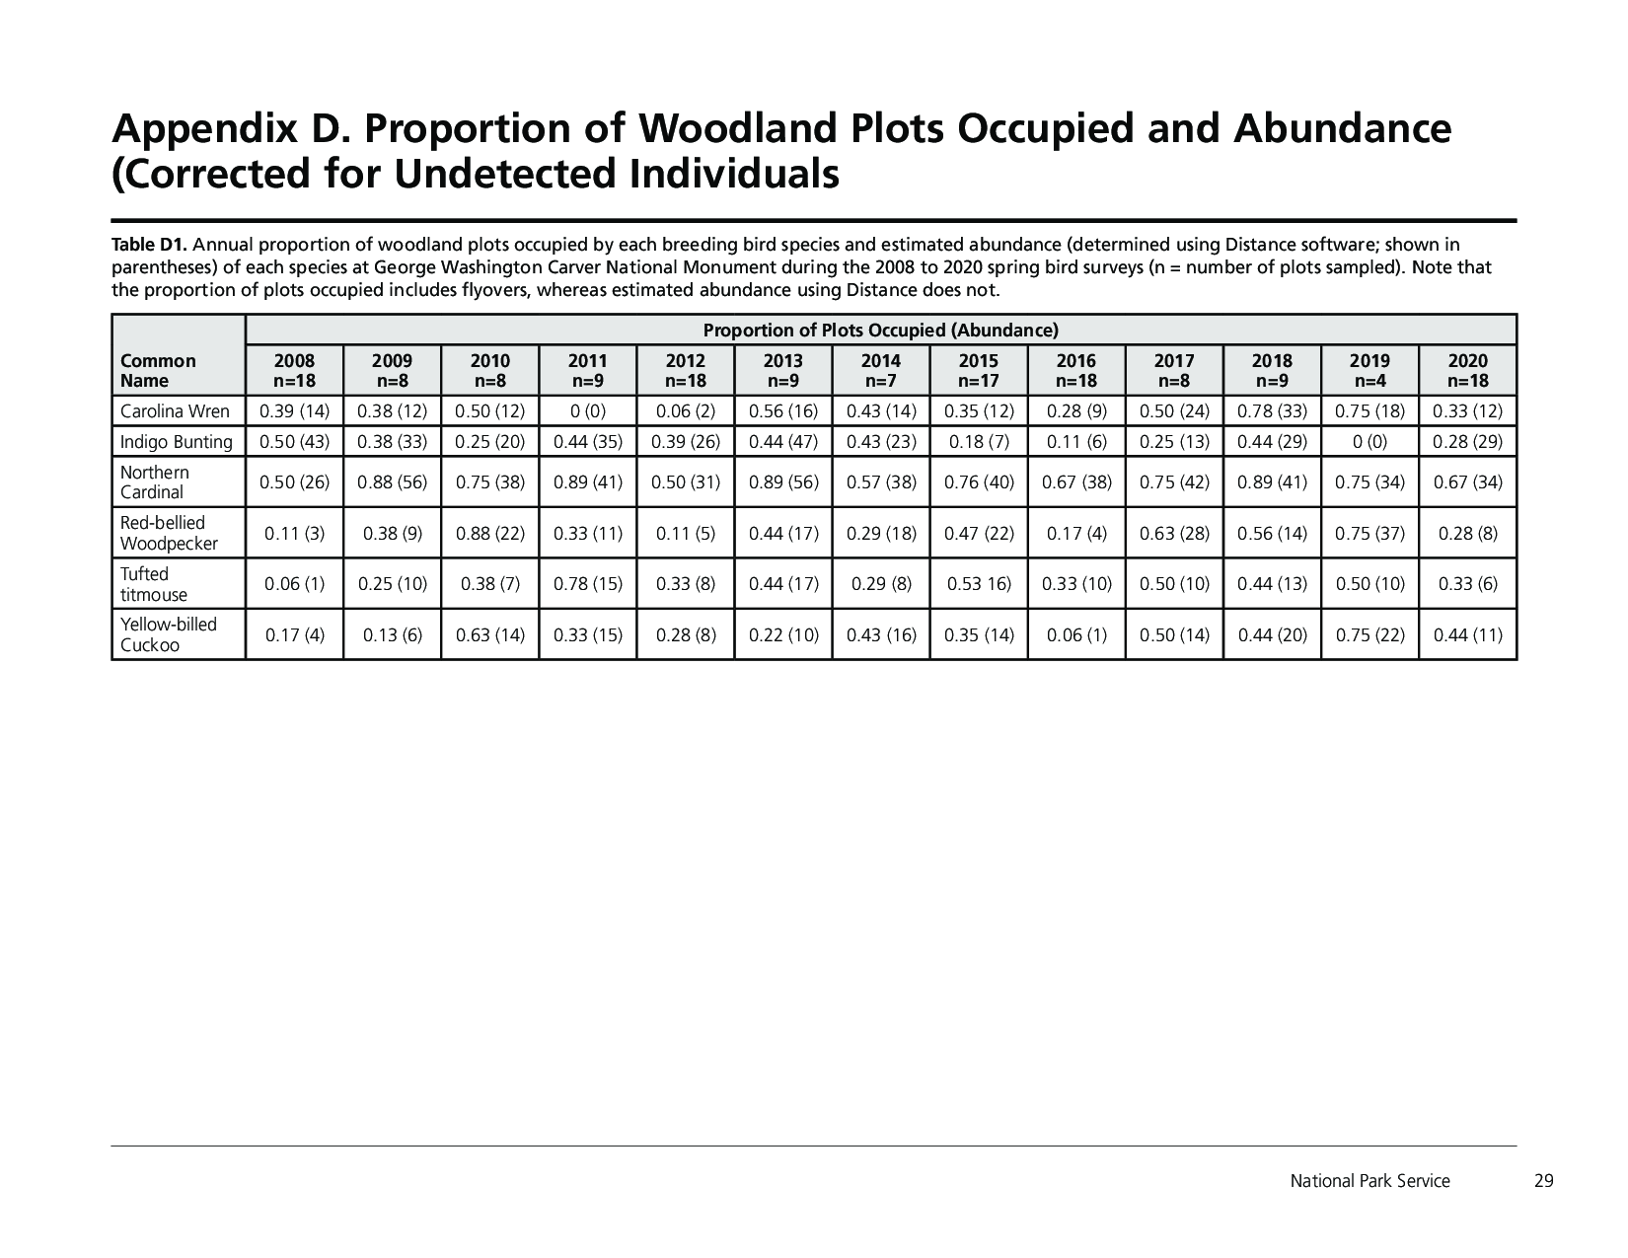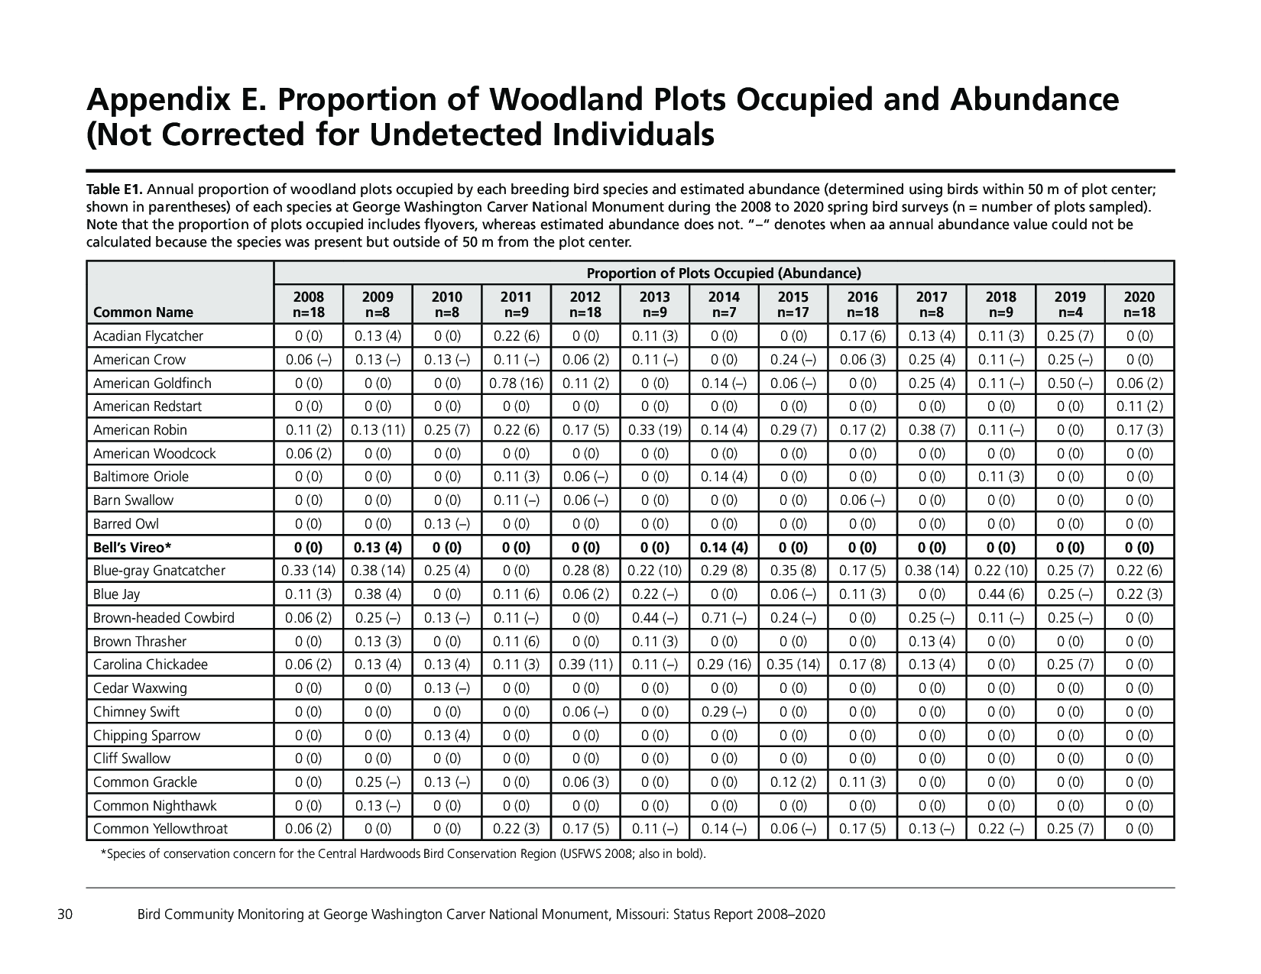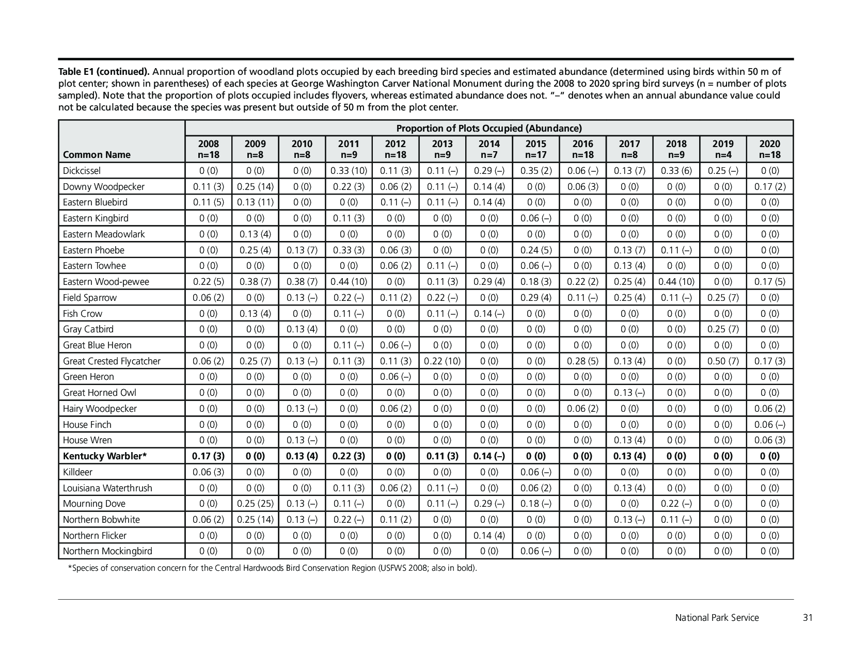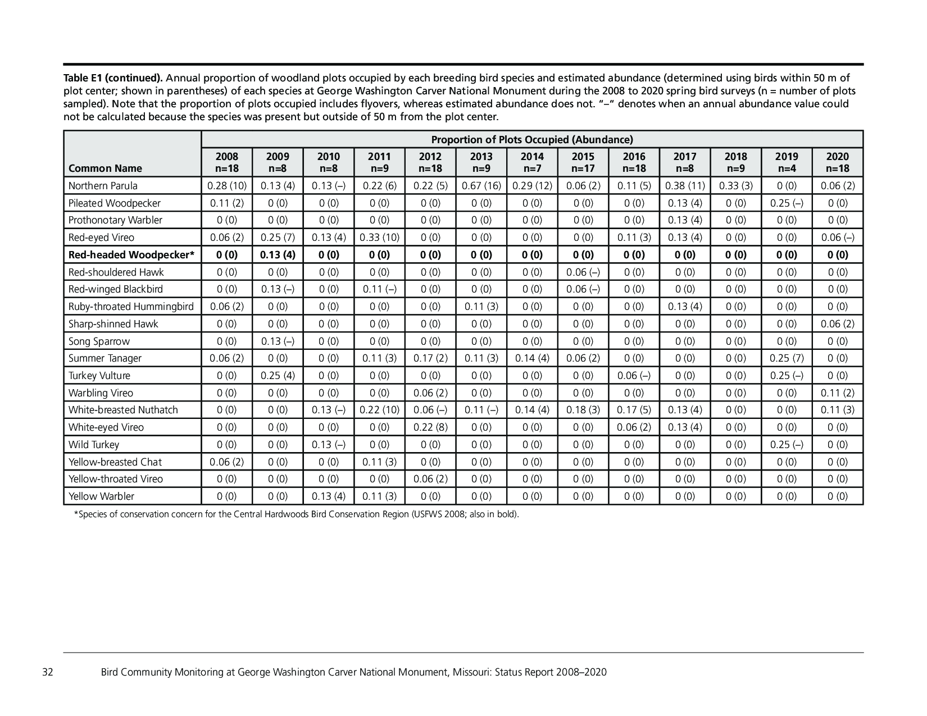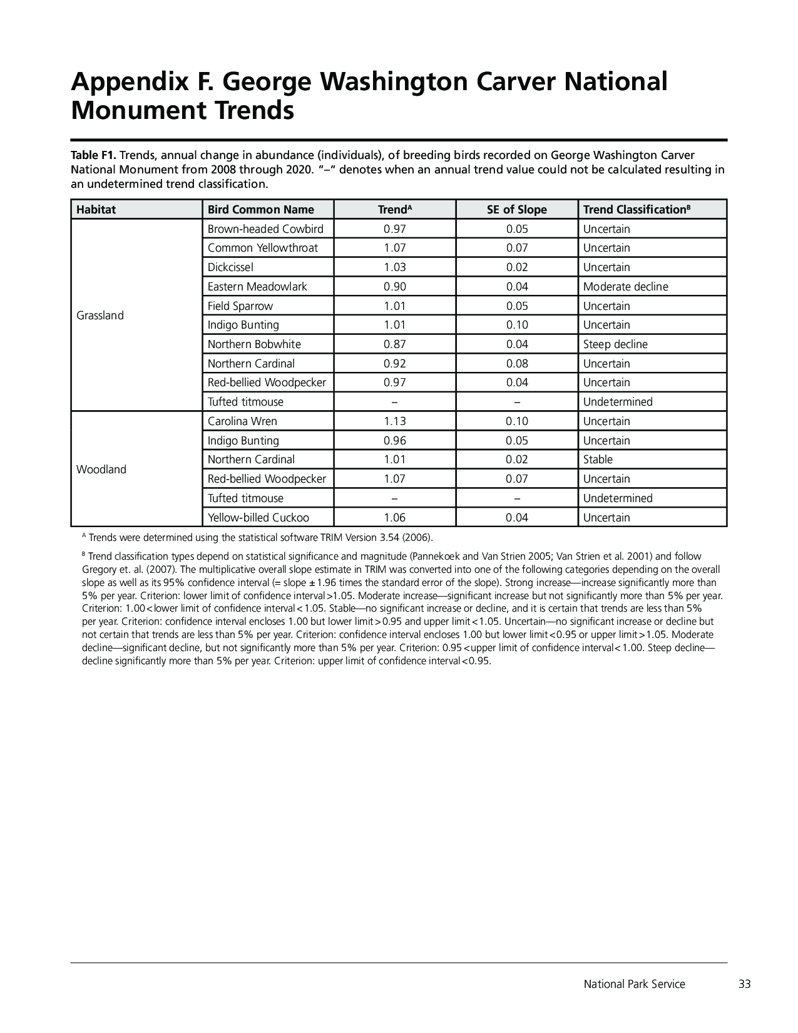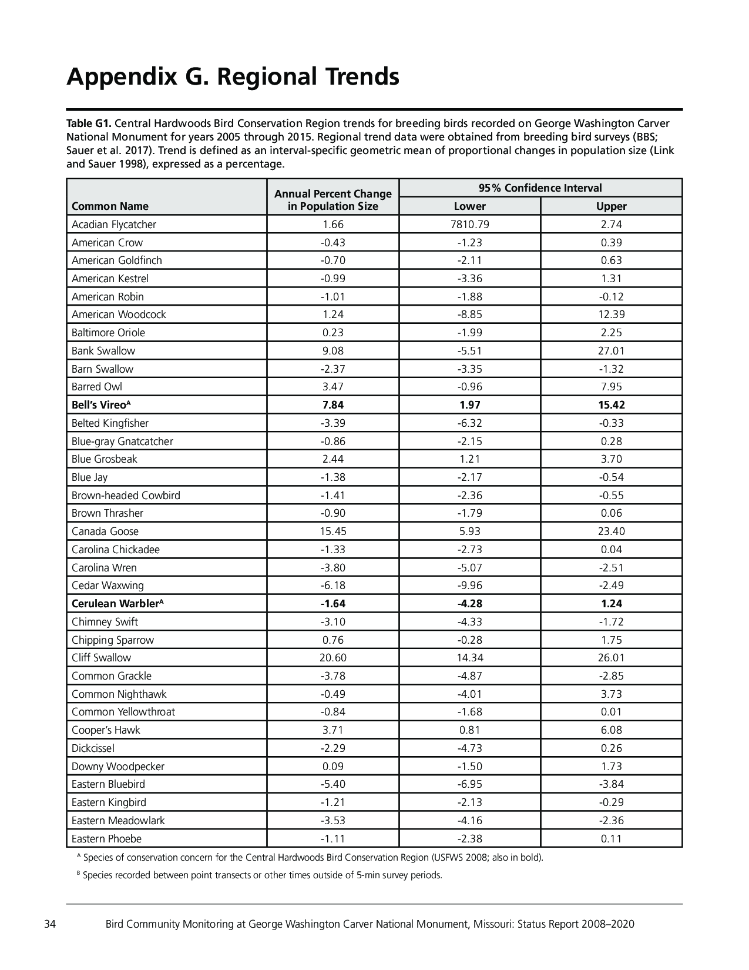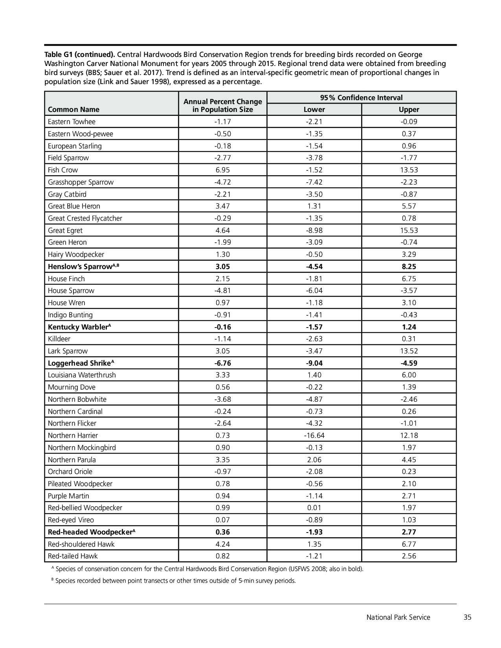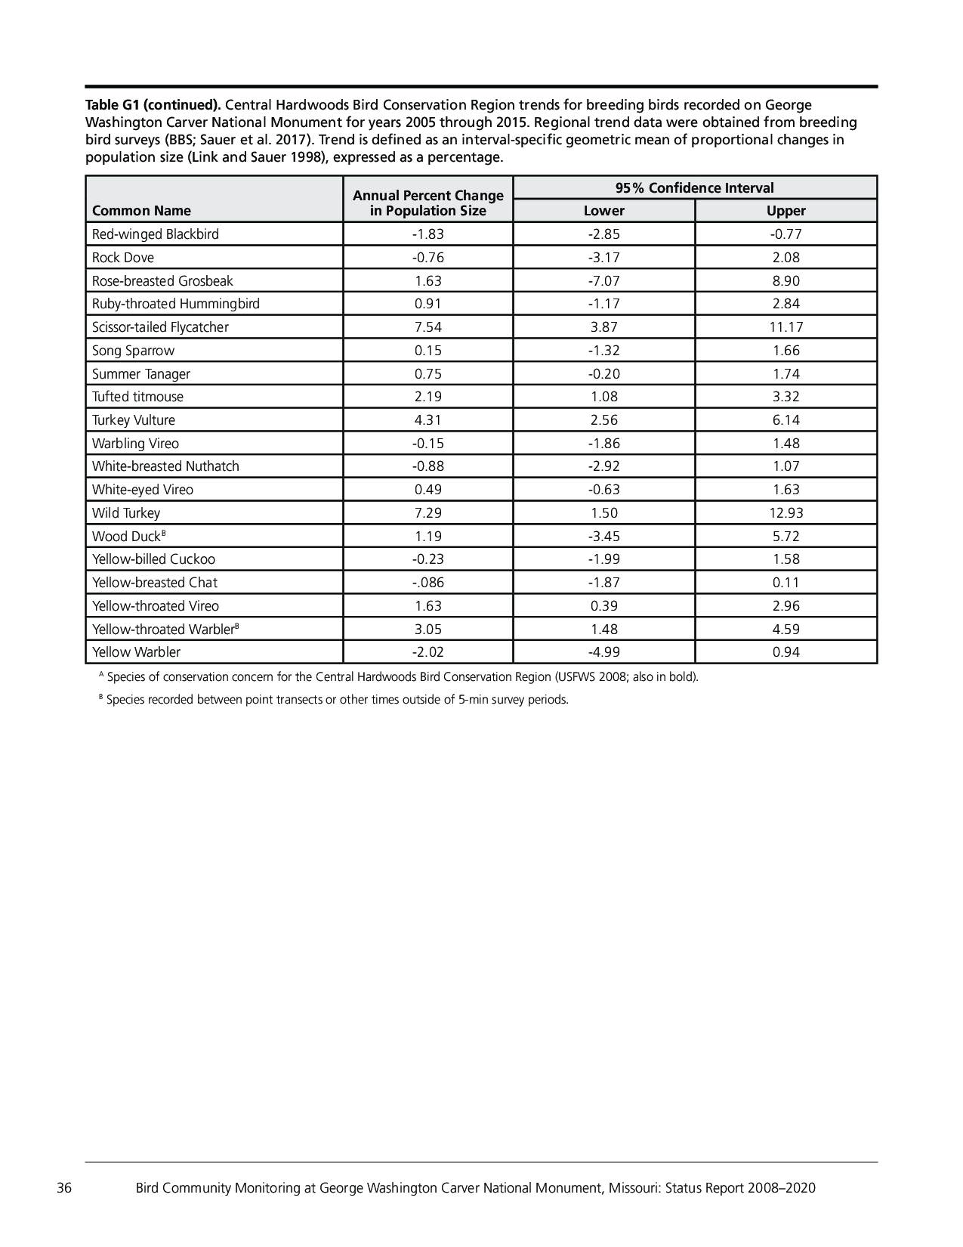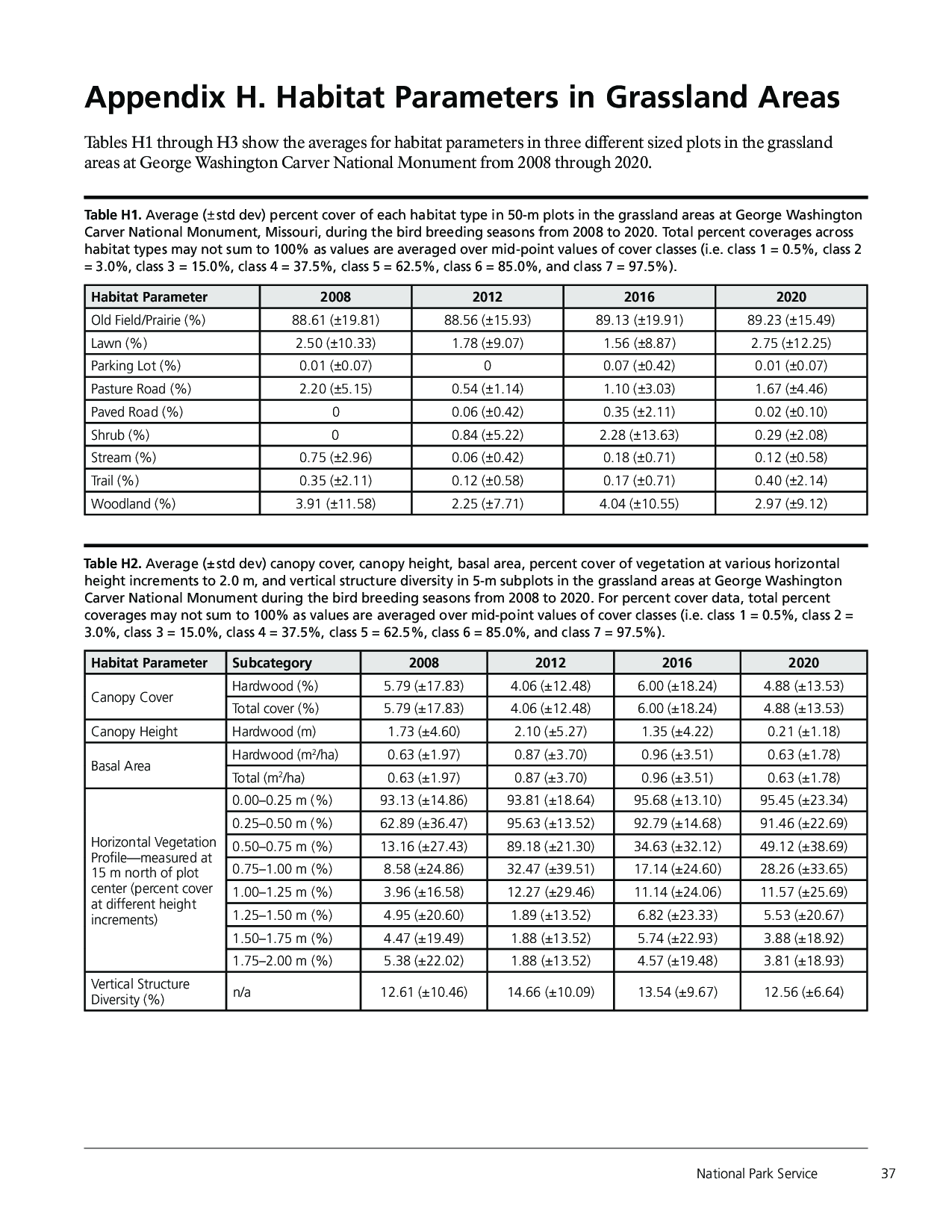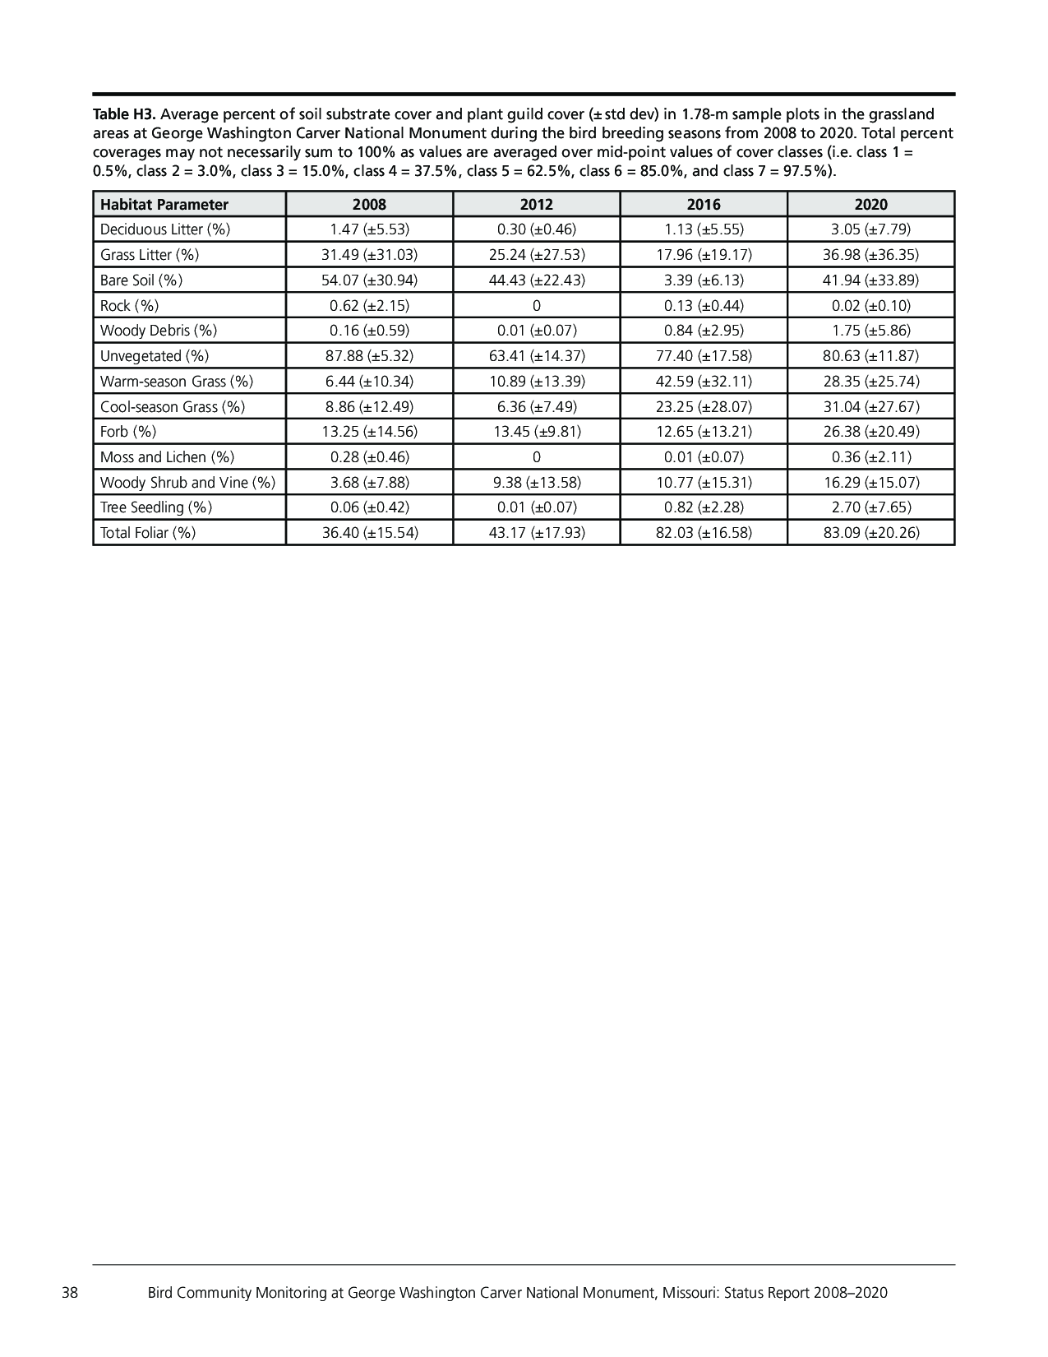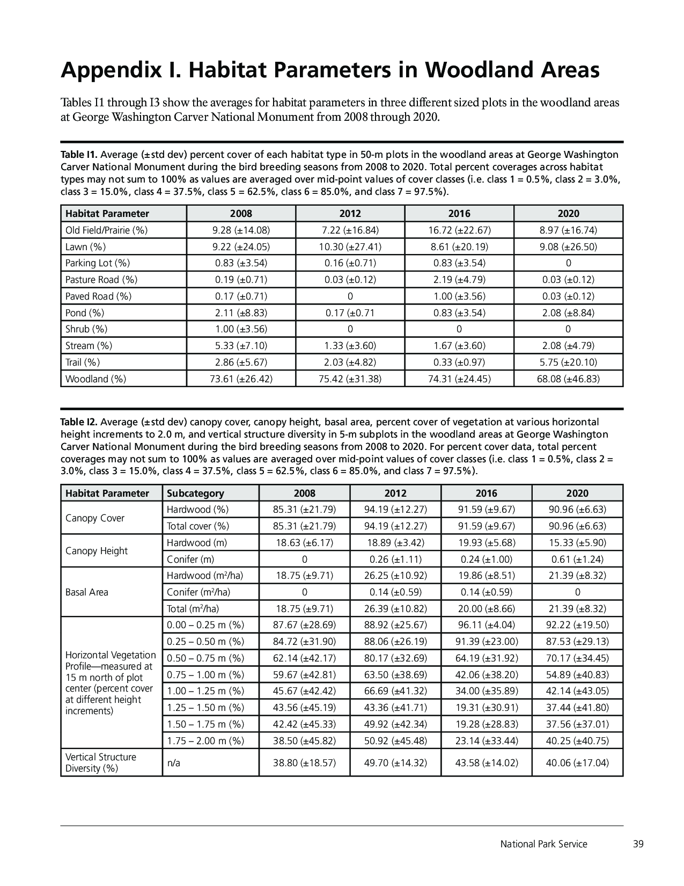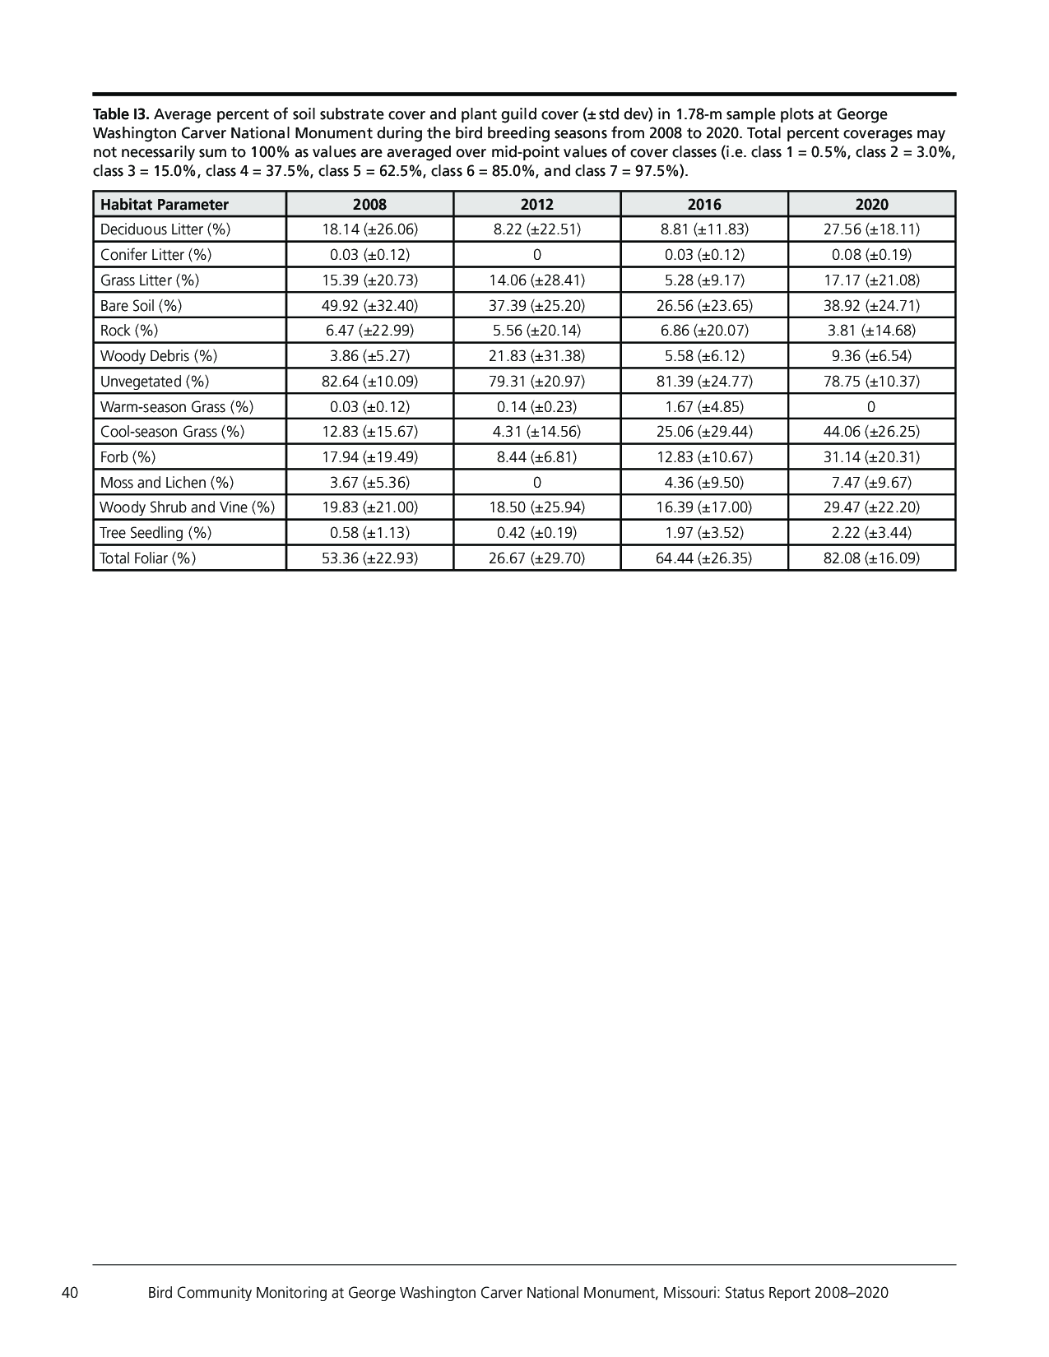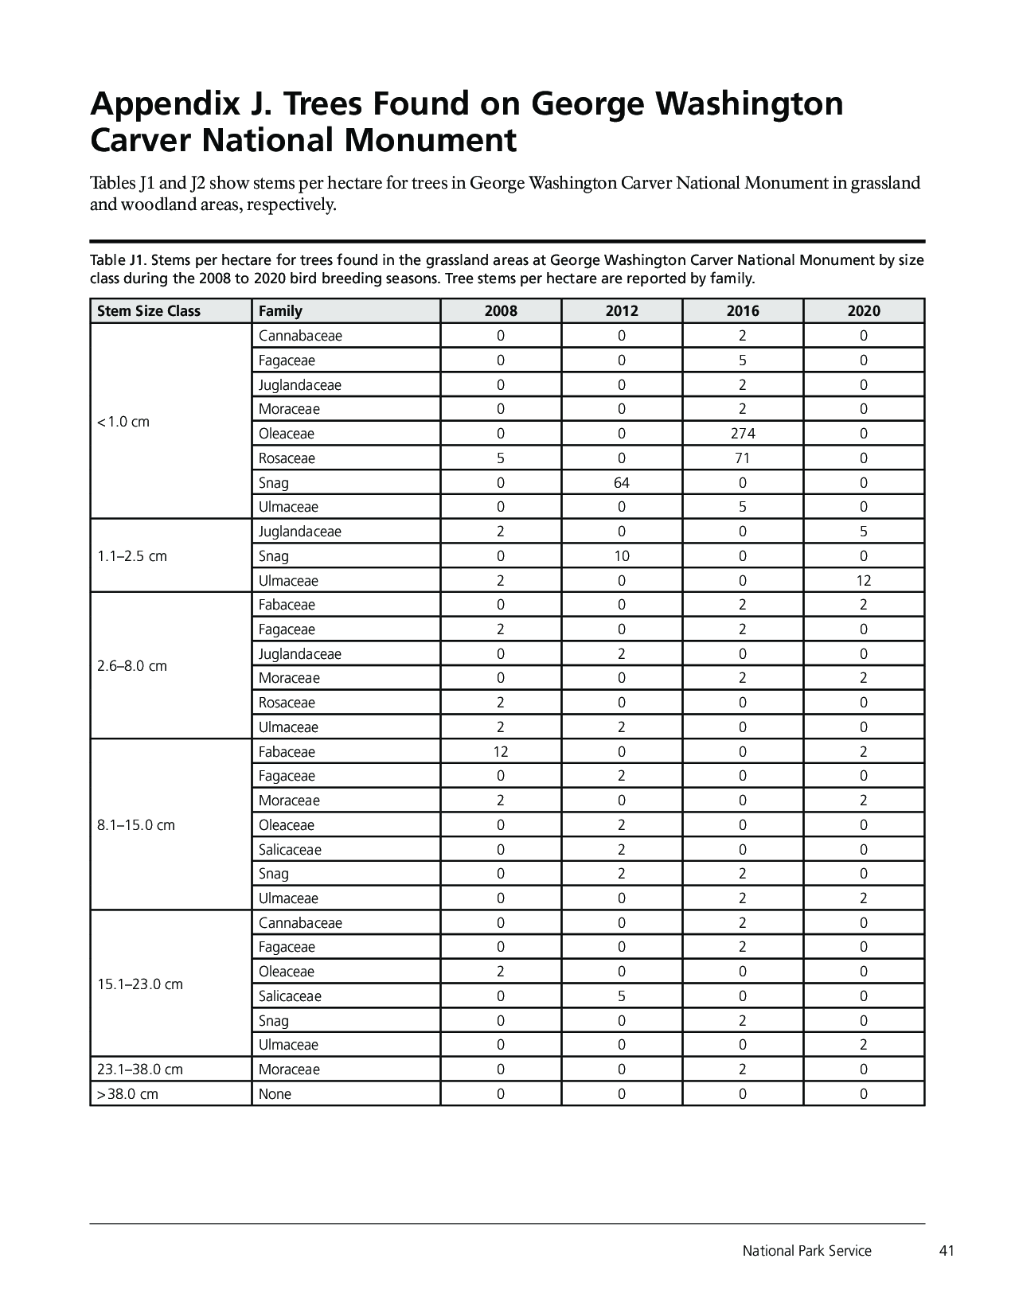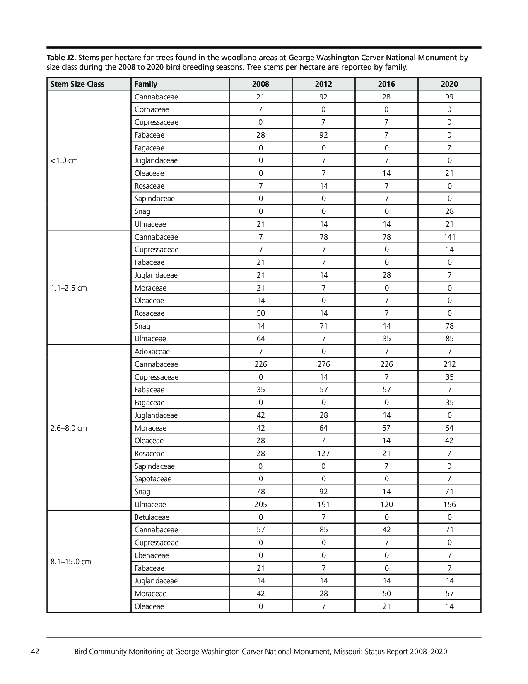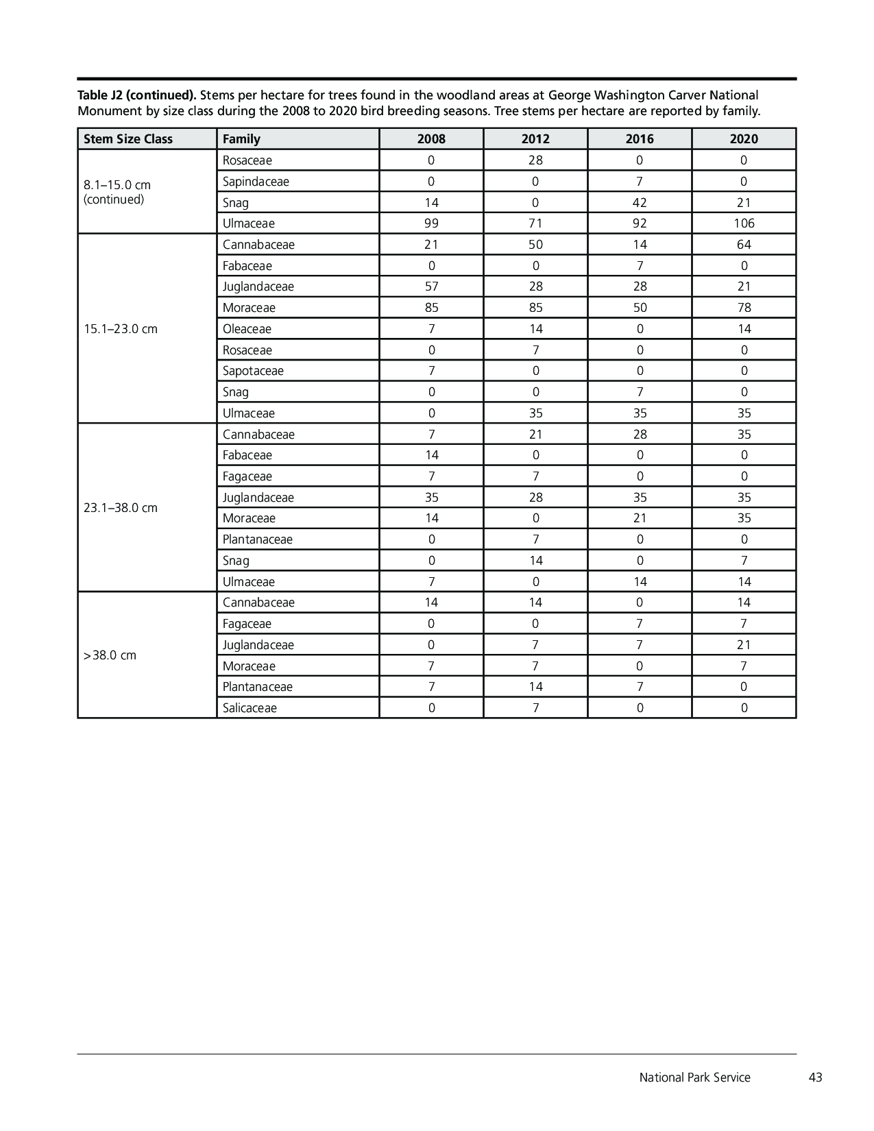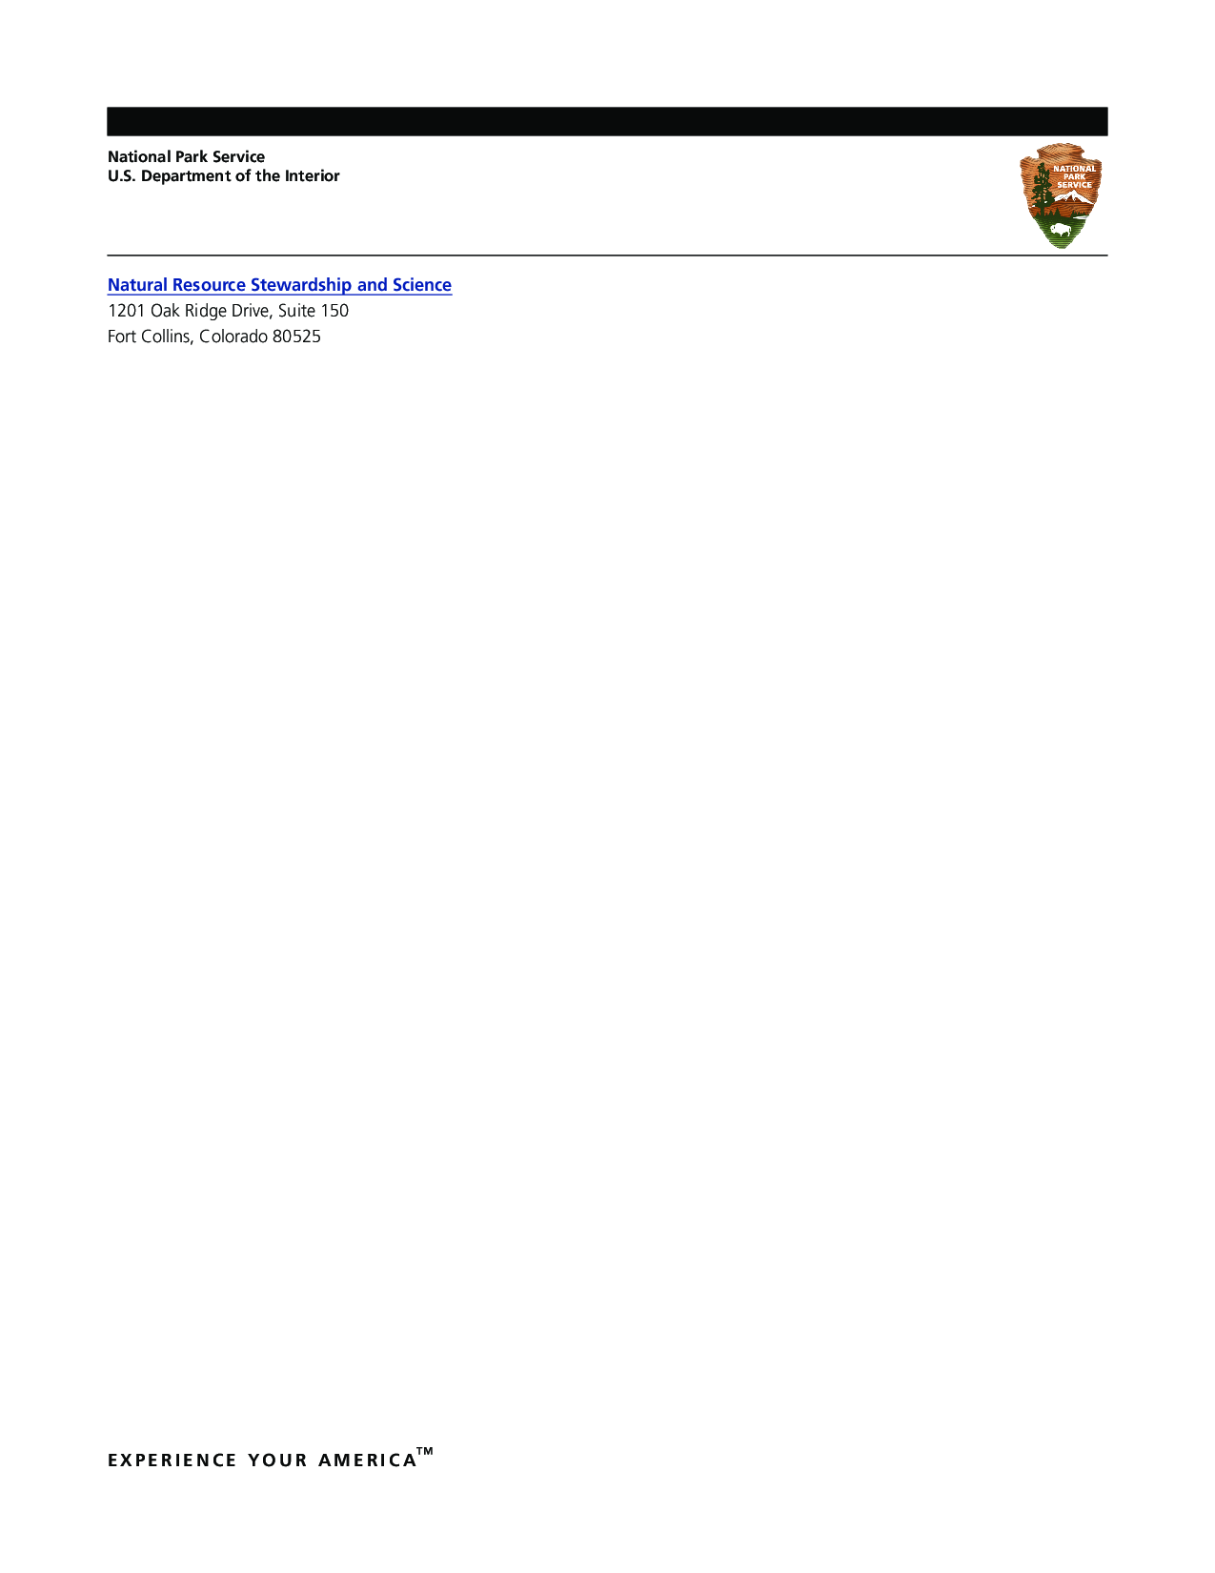

The Department of the Interior protects and manages the nation’s natural resources and cultural heritage; provides scientific and other information about those resources; and honors its special responsibilities to American Indians, Alaska Natives, and affiliated Island Communities.

NPS xxx/xxxxxx, Month 2019

|  |  |
| --- | --- |
|  | |
| National Park Service  U.S. Department of the Interior | National Park Service Logo |

**Natural Resource Stewardship and Science**

1201 Oakridge Drive, Suite 150  
Fort Collins, CO 80525

[www.nature.nps.gov](http://www.nature.nps.gov/)

EXPERIENCE YOUR AMERICA TM